Caged Drone Flight Control:

Technical Report

Team Members: Rakul Mahenthian & Richard Clapham

Date of submission: 4/19/2016

## Declaration of Authorship

The authorship of this project is essentially evenly divided in between Rick Clapham and Rakul Mahenthiran. Rakul Mahenthiran was responsible for creating the joystick and sending data to the Arduino from the android device. He is also responsible for the creation of the hardware that is compatible with the Hubsan X4 micro drone. Rick Clapham was responsible for the creation of the database and ensuring that it communicates with the android application. Rick Clapham was also responsible for the creation of the hardware that allows the application to control the Skywalker 1306 caged micro drone. The web interface will be handled by both Rakul Mahenthiran and Rick Clapham. The web interface will work in collaboration with the PHP files and database that Rick Clapham has created.

## Abstract

This project aims to resolve the lack of mobility and time consumption caused by modern filming setups. Our project will be addressing this issue using micro drones. Micro drones are small, lightweight, and fairly easy to operate with a little practice. (These drones can also be programmed to fly independently from the user however our project will not be focused on automated flight). This is the perfect filming solution because micro drones can be moved from location-to-location quickly without additional effort. We started the project by building a piece of hardware that allows us to communicate and fly the drone. The major components of our hardware build were: The Arduino Uno microcontroller, wireless transceiver, joysticks and a laser cut acrylic casing to make the hardware presentable. The second phase of our project focused on creating an application, database and web interface that utilizes our hardware. To complete the project and meet the goals, we added a light weight camera module with a 3D printed casing. The end result was having a piece of hardware supported by software allowing it to log flight data, log battery life, filming capabilities and two different controllers to operate the drone. The best part of the project is, we made these functionalities applicable on two different drone.

## Approved Proposal

### Executive Summary

As students in the Computer Engineering Technology program, we will be integrating the knowledge and skills we have learned from our program into this Internet of Things themed capstone project. This proposal requests the approval to build the hardware portion that will connect to a LAMP server as well as to a mobile device application. The internet connected hardware will include a custom PCB with sensors and actuators for a drone which will hopefully be capable of a GPS oriented automated flight. The MySQL database will store the battery life as well as run time information. The mobile device functionality will include the ability to control the drone from an Android device while allowing the user to view runtime information. In the winter semester Rakul Mahenthiran and Richard Clapham will form a group to complete the capstone project. The hardware will be completed in CENG 317 Hardware Production Techniques independently and the application will be completed in CENG 319 Software Project. These will be integrated together in the subsequent term in CENG 355 Computer Systems Project as a member of a 2 or 3 student group.

### Background

This project resolves the issue of people’s incapability of accessing and viewing selected areas. For example, without the use of a ladder you would be incapable of inspecting damages to the roof of buildings. While a ladder would solve this problem for suburban homes, when you need to inspect skyscrapers for damages it is not efficient. A drone is capable of automated flight without the need for human interaction it can be programmed to view a certain area and transmit the information wirelessly to a desktop location or another device.

While a drone can be used for simple identification and verification purposes, for example you could use a drone to inspect damages to a building in difficult to access areas rather then sending a person as stated above. However, this device has multiple applications such as aiding in search and rescue operations or just simply taking pictures of a location. The correct application of this program can greatly increase the success rate of finding people in search and rescue. A drone could also be fitted with an infrared camera and be used to detect and monitor forest fires. Amazon is currently experimenting with another use for drones; they are attempting to deliver packages using drones. This is done by simply programming the drone to take a specified path in order to deliver the package, then returning itself to a docking station. This is currently in development due to the issue of theft, the obstacles the drone may face during flight, and inaccurate GPS coordinates. The final issue with a drone delivery system is the ability to create zombie drones which are created by mounting a raspberry pi on the drone and having it emit signals that enable a user to wirelessly hack and take over another drone.

We have searched for prior art via Humber’s IEEE subscription selecting “My Subscribed Content” [2] and have found and read [3] which provides insight into similar efforts.

In the Computer Engineering Technology program, we have learned about the following topics from the respective relevant courses:

* Java Docs from CENG 212 Programming Techniques in Java,
* Construction of circuits from CENG 215 Digital and Interfacing Systems,
* Rapid application development and Gantt charts from CENG 216 Intro to Software Engineering,
* Micro computing from CENG 252 Embedded Systems,
* SQL from CENG 254 Database with Java,
* Web access of databases from CENG 256 Internet Scripting; and,
* Wireless protocols such as 802.11 from TECH152 Telecom Networks.

This knowledge and skill set will enable us to build the subsystems and integrate them together as my capstone project.

### Methodology

This proposal is assigned in the first week of class and is due at the beginning of class in the second week of the fall semester. Our coursework will focus on the first two of the 3 phases of this project:  
 Phase 1 Hardware build.  
 Phase 2 System integration.  
 Phase 3 Demonstration to future employers.

#### Phase 1 Hardware build

The hardware build will be completed in the fall term. It will fit within the CENG Project maximum dimensions of 12 13/16" x 6" x 2 7/8" (32.5cm x 15.25cm x 7.25cm) which represents the space below the tray in the parts kit. The highest AC voltage that will be used is 16Vrms from a wall adaptor from which +/- 15V or as high as 45 VDC can be obtained. Maximum power consumption will be 20 Watts.

#### Phase 2 System integration

The system integration will be completed in the fall term.

#### Phase 3 Demonstration to future employers

This project will showcase the knowledge and skills that I have learned to potential employers. The tables below provide rough effort and non-labour estimates respectively for each phase. A Gantt chart will be added by week 3 to provide more project schedule details and a more complete budget will be added by week 4. It is important to start tasks as soon as possible to be able to meet deadlines.

### Concluding remarks

This proposal presents a plan for providing an IoT solution for the lack of ability to verify and inspect building efficiently. We would like the drone to be capable of automated flight so that a programmed route could be used to view and take pictures of the surrounding area. This is an opportunity to integrate the knowledge and skills developed in our program to create a collaborative IoT capstone project demonstrating my ability to learn how to support projects such as the initiative described by [3]. We request approval of this project.

Table of Contents

Declaration of Authorship 3

Abstract 5

Approved Proposal 7

Executive Summary 7

Background 7

Methodology 8

Concluding remarks 9

1.0 Introduction 13

1.1 Purpose 13

1.2 Scope 13

2.0 Project Description 15

2.1 Project Specifications 15

2.1.1 Project Perspective 15

2.1.2 System Interface 15

2.1.3 User Interface 15

2.1.4 Hardware Interface 15

2.1.5 Software Interface 15

2.1.6 Communication Interface 16

2.2 Build instructions 17

2.2.1 Skywalker 1306 17

2.2.2 Hubsan X4 24

2.3 Feedback 33

2.3.1 Status updates feedback 33

2.3.2 Demonstration feedback 34

2.3.3 Presentation feedback 34

2.4 As built 35

2.4.1 Hardware 35

2.4.2 Database 35

2.4.3 Android Application 36

2.4.4 Web Interface 36

Conclusion 37

Recommendations 39

Bibliography 41

Appendices 43

Skywalker 1306 Arduino Sketch 43

Hubsan X4 Arduino Sketch 45

Android Application 50

Login/ Register 50

Flight Controller 61

Demo Mode 64

Flight Data 66

Web Interface 75

Website Home Page -Index.html 76

Website Manage Account Page -changepass.html 78

Website display runtime information -userinfo.php 80

Website Session Check -login_success.php 82

Website Error 1 -error1.html 83

Website Error 2 -error2.html 84

Website Error 3 -error3.html 85

Website Error 4 -error4.html 86

Website Error 5 -error5.html 87

Database PHP Files 88

Android Login -DroneLogin.php 88

Android Signup -DroneSignUp.php 89

Android Receive Data – DroneData.php 90

Android Send Start Flight -DroneStart.php 92

Android Send End Flight -DroneEnd.php 93

Website Login -checklogin.php 94

Website Register -checkregister.php 95

Website Change Password -changepassword.php 96

Website Forgot Password -forgotpassword.php 97

# 1.0 Introduction

## 1.1 Purpose

The Caged Drone Flight Control project is initially designed to aid in filming and monitoring. However, due to the small size of the drone it is incapable of supporting a module to transmit the data. So the project has become focused on the data manipulation and control of the caged micro drone. The project will focus on creating a flight controller for the drone, using physical hardware and software applications. Our project will have a hardware component, a database, a web component and finally an android application designed for reading data and controlling the drone.

## 1.2 Scope

The project will be capable of controlling the Skywalker 1306 or Hubsan X4 micro drone using an Arduino. The database will contain runtime information such as the when the drone was last ran and how long it ran for. The Flight Controller application will be able to view runtime information such as your flight schedule, flight path, battery life and will be capable of controlling either drone from an android device. The web interface will allow the user to review runtime information and provide real-time updates.

# 2.0 Project Description

## 2.1 Project Specifications

### 2.1.1 Project Perspective

Our project is a component to a larger system that helps meet the objective. The project size guidelines restrict us from being able to mount a camera module capable of wireless video transmission capabilities. The size of the drone is incapable of supporting the weight of these components; however, we did manage to mount a camera module without wireless streaming capabilities.  Aside from wireless video transmission, we have covered all other aspects of the system we aimed to create. Our hardware, application, database and web interface will work in uniform to deliver a unique product to the market.

### 2.1.2 System Interface

The system as a whole is capable of operating as individual parts or as an entire system. The hardware built using the Arduino micro-controller will allow for control of the drone independently or along with android device. While the web interface and android application can operate without the Arduino; however, without the Arduino the Android application will only be able to view runtime information.

### 2.1.3 User Interface

The application provides a very easy to use user interface.  Upon entering the android application, it will consist of two options to either login, register or sign in as a guest. The guest user will be incapable of viewing and logging runtime information but they will be able to control the drone. If a user signs in they will have the option to use the flight controller, perform troubleshooting or view runtime information such as flight time, approximate battery life and flight path.

### 2.1.4 Hardware Interface

The project consists of two pieces of hardware, one for the Hubsan X4 and the other for the Skywalker 1306. Both hardware’s serve the same purpose of communicating with the drone; however, they use slightly different approaches. They are similar in the sense, both hardware’s operate using the Arduino UNO microcontroller. However, the hardware controls on the Skywalker 1306 use two joysticks to control the throttle, yaw, pitch and roll. On the Hubsan X4 the hardware controls use one joystick to control throttle and yaw, and an accelerometer to control pitch and roll. The code which the microcontrollers operate under share a similar sequence for collecting control inputs, thus making the compatibility of both hardware’s well suited for the android application.

### 

### 2.1.5 Software Interface

The software we designed is capable of controlling either the Skywalker 1306 or the Hubsan X4. The Arduino program is capable of operating the drone independently from an android device; however, if you’re only using the Arduino the software will be incapable of communication with the database. The android application will control either drone as well as be able to view the runtime information of the drone. Finally, the web interface will allow the user to view their runtime information.

### 2.1.6 Communication Interface

The communication interface between the both drones and wireless transceivers is through SPI. The Arduino sketch generates 8-byte packets based on user input and connection status. The packets transmitted support 8-bit resolution flight control inputs. While, the Android device communicates with the database over wifi or mobile network.

## 2.2 Build instructions

### 2.2.1 Skywalker 1306

#### 2.2.1.1 Introduction

The Skywalker 1306 is a micro drone that has been surrounded with a cage in order to prevent damage to the propellers. The drone is 230mm x 220mm x 220mm in size when inside the hamster cage this makes it small in size and relatively harmless if it does crash into anything. As a student in the Computer Engineering Technology program, I will be integrating   
the knowledge and skills I have learned from the computer engineering and technology program at Humber Institute of Technology and Advanced Learning in order to take control of the drone using an Arduino and Android device. The project will eventually include an Android application, mySQL database, web interface and a hardware portion. In this section of the technical report there will information telling you how to recreate the hardware used to control the Skywalker 1306 hamster cage drone.

#### 2.2.1.2 Required Materials

* Skywalker 1306 All Inclusive Kit

(This includes the Skywalker 1306 drone, controller, 1 x 3.7V 300mAh Lipo Battery, Lipo USB charging cable)

* Arduino UNO R3 Micro Controller
* Arduino Serial Cable
* Female USB to male Micro USB cable
* Android Device
* Optionally you can purchase a BK2421 transmitter as that is the transmitter used in the controller. (I am currently unaware of any location still selling them) or it is recommended that you purchase a spare Skywalker 1306 controller.

#### 2.2.1.3 Time Commitment

The required time in order to recreate the hardware used to control the Skywalker 1306 hamster cage drone is approximately 1-2 hours. However, if you do not know how to solder or are having difficulties I would strongly recommend the you practice soldering in advance or get in contact with someone that has experience soldering.

#### 2.2.1.4 Mechanical Assembly

In order to successfully assemble the hardware to control the Skywalker 1306 you simply need to follow the below steps:

1. Acquire the required materials and parts.
2. Before you begin disassembling your materials you need to test the drone and controller. This can be done by performing a simple test flight in order to ensure that both the drone and controller are communicating with each other. If there are issues binding the drone to the controller take the necessary steps to return the hardware.
3. If you have already have a BK2421 transmitter you do not need to perform the following instruction. If the drone and controller are communicating with each other you can begin disassembling the controller. To disassemble the controller, you simply need to unscrew the controller and then extract the BK2421 transmitter which is hidden behind a PCB inside the controller. The BK2421 transmitter is circled in the image below. The transmitter is normally held in by glue which can simply be reheated with a soldering iron to remove.

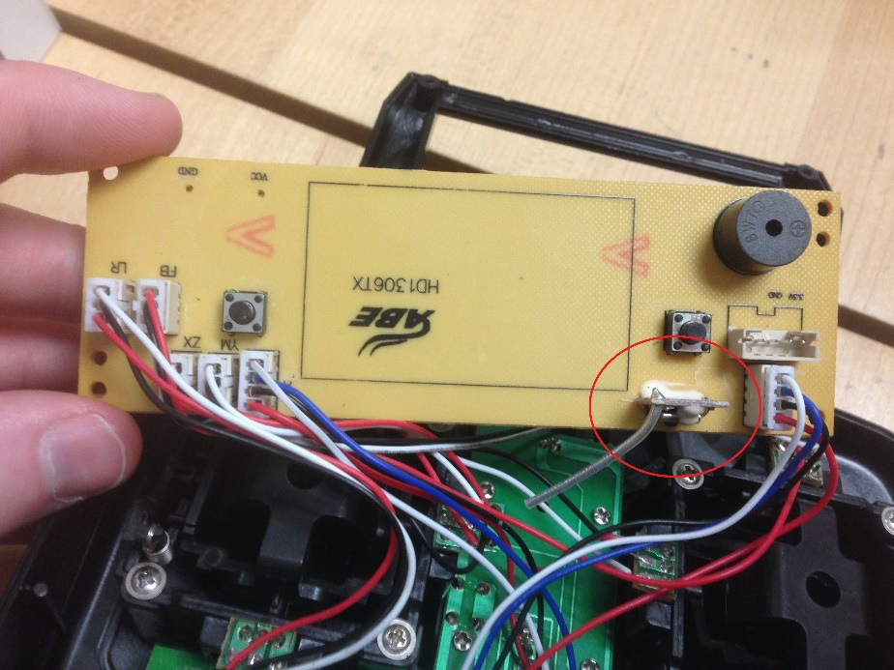

1. After extracting the BK2421 transmitter from the controller you simply need to solder 24 gauge or thinner wires to each pinout of the transmitter. (Do not use 22 gauge or thicker as you will risk destroying or ripping off a pad on the BK2421 transmitter which will destroy the transmitter). Below is a picture of how the transmitter should look when completed both front and back. (Optionally you can also extract the joysticks from the controller if you want to create a custom controller suing the Arduino)

|  |  |
| --- | --- |
| C:\Users\Rick\Downloads\BK2421Front.JPG | C:\Users\Rick\Downloads\BK2421Back.JPG |

1. After soldering wires to the BK2421 transmitter you will then need to connect the transmitter to the Arduino. Simply do this by connecting the wires to the Arduinos pinouts the diagram below will list the exact location on the Arduino to connect the BK2421 transmitter. After performing this step, the hardware to control the drone from an Android device is completed however by performing steps 6 and 7 you will be able to control the drone using a custom built controller using joysticks and the Arduino.

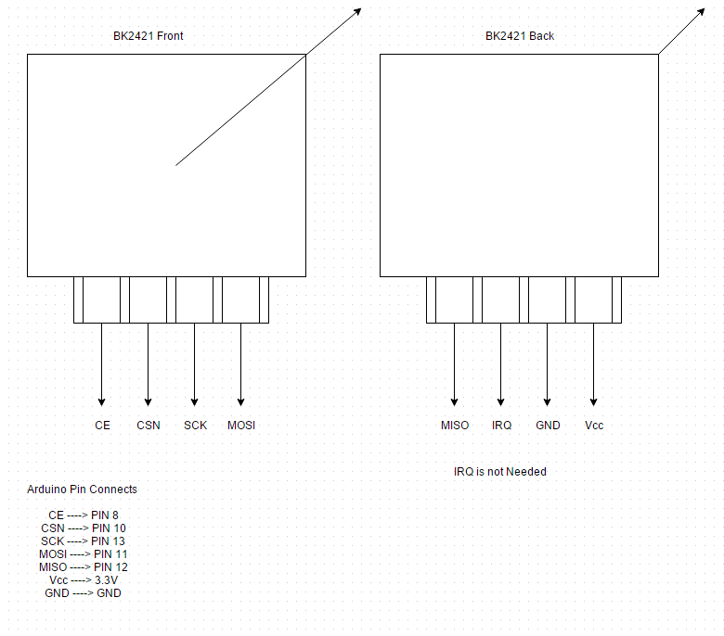

1. If you are going to build a custom controller using the Arduino, then you will then need to solder wires onto the joysticks you have extracted. It is recommended that you color code the wires so that Vcc is red, ground is black and the output is green. (Green is the color is used however any color is viable so long as it is consistent). You can use a multi-meter to determine which pin is ground and Vcc while the middle pinout should always be the analog output.
2. You will then need to attach the joysticks to the Arduino. The diagram below will show the exact pinout they are connected to in order for the controller to function correctly.

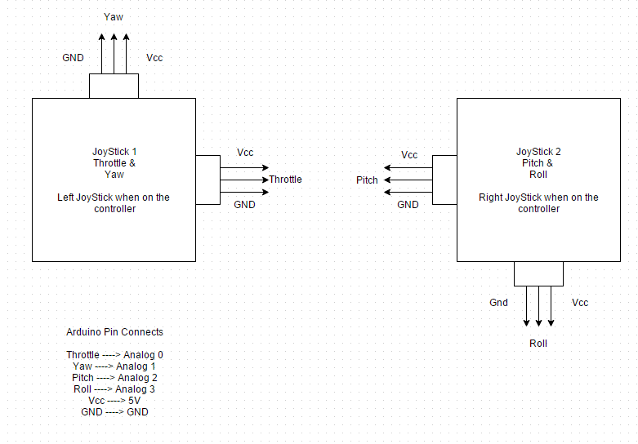

1. Finally, you simply need to perform a check of the Arduino to ensure that the hardware is setup correctly. Below is another diagram that should show you the final pin layout of the Arduino. Please note that joysticks pinouts are only required if you plan on building a custom controller for the drone. Also, the serial cable connection is no longer going to a raspberry pi but to an Android Device of your choice.

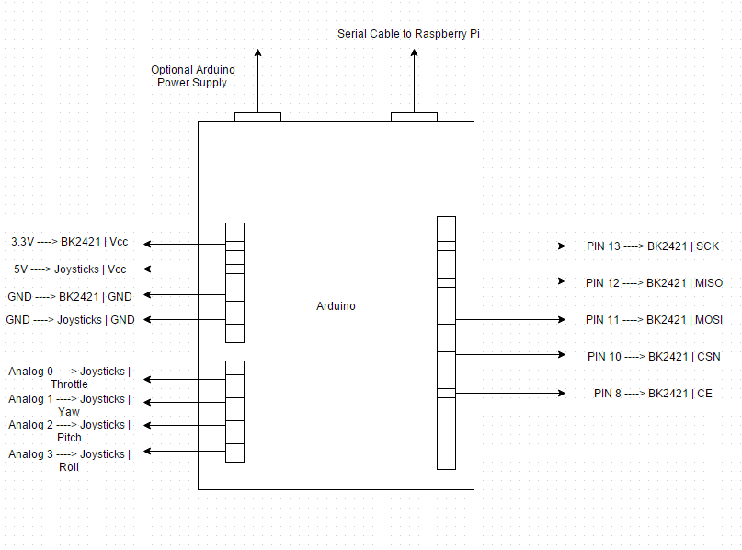

#### 2.2.1.5 PCB / Soldering

There is an optional PCB you can build in order to create a custom built controller however I have unfortunately lost the files however below is a picture of a single sided PCB that you can create in order to assemble a controller. In the final assembly of the project I opted to simply control the drone through an Android application and that is why the PCB and joysticks are no longer is use.

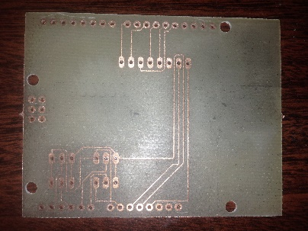

#### 2.2.1.6 Power Up

Before powering up the Arduino perform a final check of the Arduino circuit in order to ensure that everything is connected properly and circuit doesn’t have any shorts. Things to note during this stage is that the BK2421 is 5V tolerant however it should be using 3.3V. Finally, if the circuit appears to be fine upload either the SkywalkerAnalog or SkywalkerAndroid source code to the Arduino. (SkywalkerAnalog for the micro controller variant and SkywalkerAndroid if you would like to control the drone using your android device.)

Then simply power on the drone and stop the drone from moving. When the drone remains stationary it should immediately begin binding to the Arduino. Finally, the Skywalker 1306 drone will have 2 LED’s located on the front of the drone that be used to determine the state of the drone. (Useful for unit testing later)

1. Lights are off – The drone is out of battery or has no battery connected
2. Lights flashing at 5Hz – The drone is not bound and is currently not attempting to bind
3. Lights flashing at 25Hz – The drone is currently attempting to bind to the Arduino.
4. Lights are on – The drone is currently connected to the Arduino and should be useable.

#### 2.2.1.7 Unit Testing

If there is a problem with the hardware and you are having difficulties binding the drone and the Arduino, you will need to unit test your circuit in order to determine the cause of the problem.

The most likely cause of your problem is the BK2421 transmitter. The first thing you check if you are having problems is the transmitters pads if a pad is missing there is unfortunately no way to repair the transmitter and you will simply need to replace it. However, if it is simply a loose wire you can simply reconnect it and attempt to establish connection.

If you are using a custom built micro controller and the drone is binding to the Arduino correctly however the drone is not flying in the correct direction it is most likely because you have incorrectly setup the Arduino’s analog inputs. Simply check the Arduino diagram to ensure you have the correct analog input in the correct location. If the analog inputs are correct you are still flying incorrectly you have most likely reversed the ground and Vcc for the joysticks simply reverse them and you should be working correctly again. If everything is correct above is correct however only one of the joysticks isn’t working correctly, simply reverse the ground and Vcc of that joystick.

If you are flying the drone using an Android device the only hardware problem that can occur is that the bK2421 transmitter is damaged or that the drone isn’t connected with the Arduino correctly. To connect the drone to your Android device correctly simply refer to the instructions on the Android application to correctly connect to and control the drone.

#### 2.2.1.8 Production Testing

To do a final production test of the drone simply attempt to fly the drone using either your custom built micro controller or using an Android device. If the drone is binding and flying correctly, then your hardware is working correctly.

### 2.2.2 Hubsan X4

*2.2.2.1 Introduction*

The Hubsan X4 is palm sized micro drone, that considered to be a reputable entry level drone. Throughout the course of the build, I found the drone to be very well built and durable. Thus making this drone perfect for hardware and software integration.

*2.2.2.2 Time Commitment*

The assembly of the Hubsan’s Flight controller can be assembled within four hours; however, as I have learned things are easier said than done. It would be best to pace the build over the course of several days. This would allow you to ensure the connections are correct and secure, thus prevent the need for future troubleshooting.

*2.2.2.3 Required Materials*

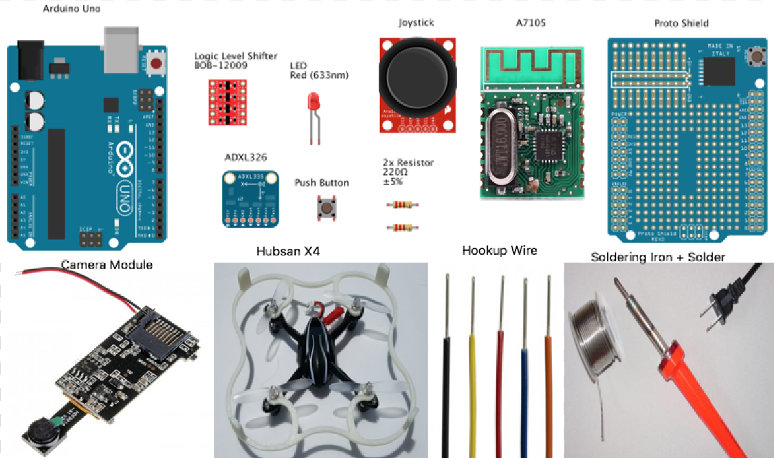

* Hubsan X4 micro drone
* 3.7V 380mAh Lipo Battery
* Arduino Uno Microcontroller
* A7105 Wireless Transceiver
* 5V to 3.3V Logic Level Shifter
* ADXL326 Accelerometer Module
* Joystick, without vertical reset to center
* 2 x 220 ohm Resistors
* LED
* Push Button
* Proto Shield
* Camera Module
* Jumper Cables and JST connectors
* Solder and Soldering Iron

Recommendations:

* Having more than one Lipo battery will be very convenient for testing, as each battery only provides an approximate battery life of seven minutes
* The pins on the A7105 wireless transceiver are very fragile and tend to break, it is recommended to buy more that one since they are fairly cheap
* The left joystick can be desoldered from the existing radio controller for the Hubsan
* The Proto Shield is not a mandatory requirement; a breadboard can be used instead. However, the proto shield does help make the hardware look more clean and presentable.
* It is recommended to have a serial cable, OTG cable and android device available for the next stage, software integration

*2.2.2.4 Mechanical Assembly*

The following instructions show how the Hubsan’s Flight Controller Hardware is assembled. Before beginning the assembly of the Flight Controller, I would highly recommend creating a prop guard or a cage for the drone’s protection. In comparison to the Skywalker 1306, the Hubsan lacks a protective cage, thus making it more vulnerable to damage in the event of a crash. When building the flight controller, I would first suggest building the circuit on a breadboard. Then test the circuits functionality and proceed to soldering it on the Proto Shield.

**Phase 1:** Flight Protection

In order for the safety of the drone and the people around it, it is essential to have a prop guard. The prop guards shown in Figure 1.1 and 1.2 were made using a 3D printer and the help of Anthony Nyman.

Figure 1.1 Figure 1.2

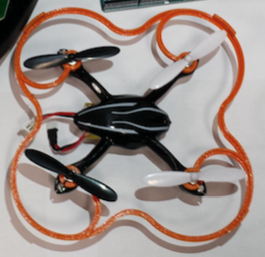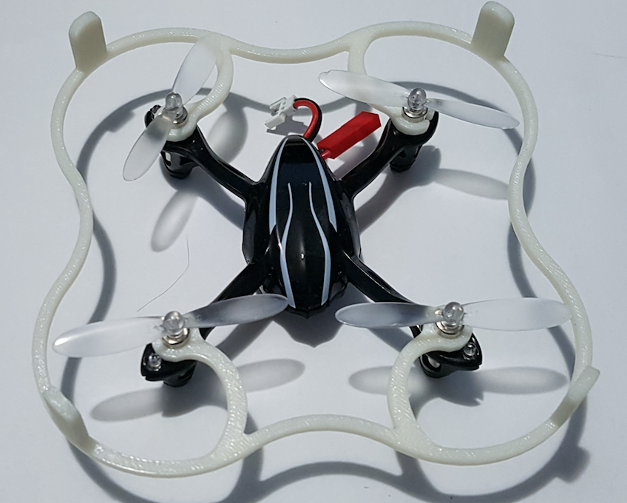

**Phase 2:** Prepping A7105

Looking at Figure 2.1, solder seven pieces of equal length solid core wire to the pins indicated with a green dot. These seven pieces of wire will act as legs allowing you to place the chip on a breadboard. This task can be very challenging to individuals unexperienced in soldering, like myself. I found it to be easier if you applied a little solder to the pin and wire, then heated the two components together to make the connection. The final product should be similar to what is shown in Figure 2.2

Figure 2.1 Figure 2.2

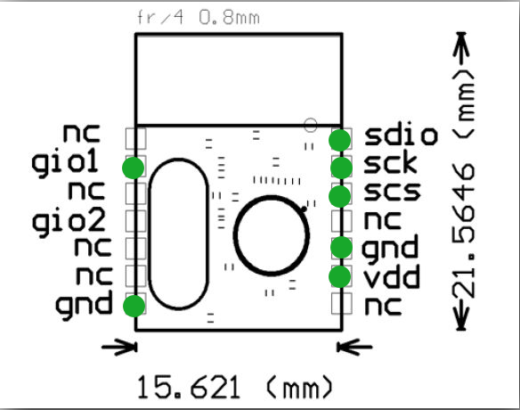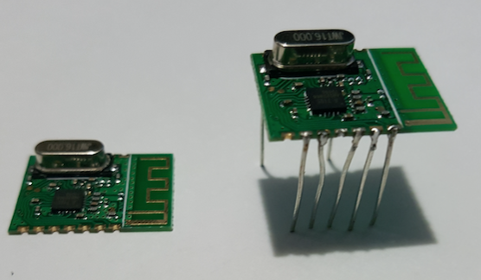

**Phase 3:** Connecting A7105 to Arduino

Figure 3.1 shows the connections made to allow the Arduino to communicate with the A7105 wireless transceiver using SPI. The first step is to safely sit the pins of the A7105 on the breadboard. Next, place the logic level shifter on the breadboard. The level shifter allows the Digital 5V output from the Arduino to be stepped down to a safe 3.3V for the A7105. Now that all the components are set in place, make the following connections between the Arduino, level shifter and A7105 (If needed, reference to Figure 2.1 to identify pin outputs on the A7105).

1. Connect both GND pins on the A7105 and the level shifter to the GND pin on the Arduino.
2. Connect he 5V pin from the Arduino to the HV pin on the level shifter
3. Connect the 3.3 pin from the Arduino the LV pin on the level shifter and the VDD pin on the A7105
4. Blue wire in Figure 3.1:

Pin 10 on Arduino 🡪 HV1 on level shifter

LV1 on level shifter 🡪 SCS on A7105

1. Orange wire in Figure 3.1:

Pin 11 on Arduino 🡪HV2 on level shifter

LV2 on level shifter 🡪 SDIO on A7105

1. Yellow wire in Figure 3.1:

Pin 12 on Arduino 🡪 HV3 on level shifter

LV3 on level shifter 🡪 GIO1 on A7105

1. Green wire in Figure 3.1:

Pin 13 on Arduino 🡪 HV4 on Level shifter

LV4 on level shifter🡪 SCK on A7105

Figure 3.1



**Phase 4:** Connecting Hardware controls to Arduino

Figure 4.1 shows the connections made to use the physical hardware controls as analog inputs. The vertical movement of the joystick control the throttle; the horizontal movements controls the yaw(rotation). The ADXL326’s X and Y directional readings are used as analog inputs to control the pitch (forward and backward movement) and roll (left and right movement). The push button is used to signal calibrating the ADXL326 accelerometer when its pulled to low, and the LED indicates it is calibrating. The following connections are made between the Arduino and the accelerometer and joystick.

1. ADXL326
2. Pink wire: 3Vo on ADXL326 to AREF on Arduino
3. Red wire: Vin on ADXL326 to 5V on Arduino
4. Black wire: GND on ADXL326 to GND on Arduino
5. Green wire: Zout on ADXL326 to A2 on Arduino
6. Orange wire: Yout on ADXL326 to A1 on Arduino
7. Brown wire: Xout on ADXL326 to A0 on Arduino
8. Joystick
9. Red wire: Vcc on joystick to 3.3V on Arduino
10. Purple wire: Vertical input on joystick to A3 on Arduino
11. Yellow wire: Horizontal input on joystick to A4 on Arduino
12. Black wire: GND on joystick to GND on Arduino
13. Push Button
14. One end is connected to Pin2 on Arduino and a 220-ohm resistor then the 5V on the Arduino
15. The other end is connected to GND on the Arduino
16. LED
17. Connect the anode of the LED to a 220-ohm resistor then to pin 7 on Arduino
18. Connect the cathode of the LED to GND on the Arduino

Figure 4.1

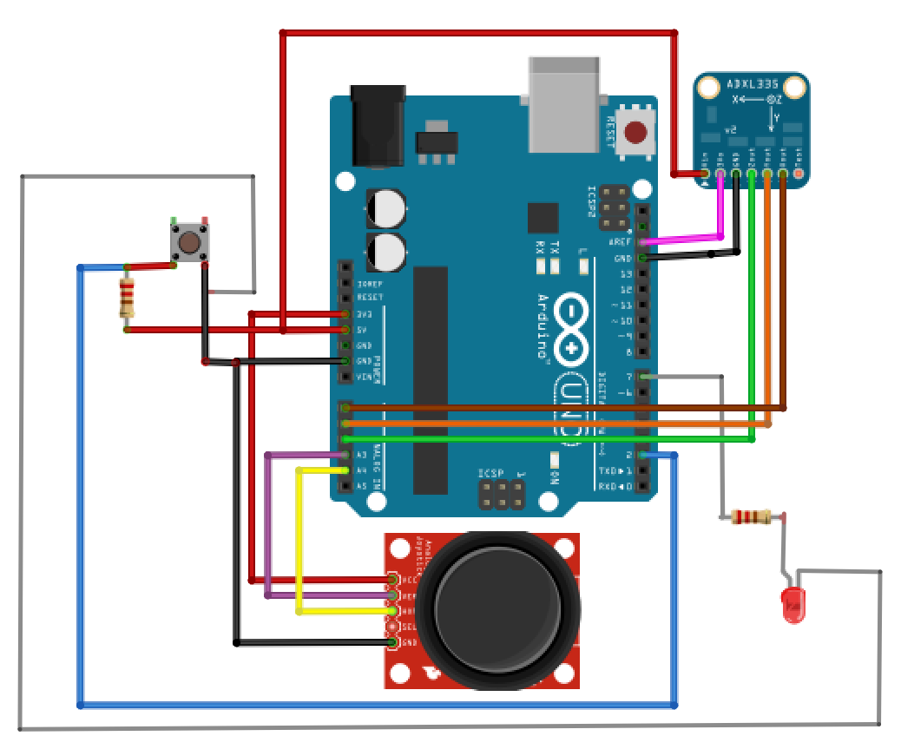

**Phase 5:** Moving Circuit from Breadboard to Proto Shield

At this point the circuit for the Flight Controller is complete. The circuits functionality was tested using the guidelines from section 2.2.2.6 Power Up and 2.2.2.7 Unit Testing. If everything works accordingly the circuit can be soldered onto the Proto Shield as shown in Figure 5.1. I created an acrylic casing and a PCB to mount the joystick (discussed in section 2.2.2.5 PCB Soldering) to finish up the controller and make it more presentable. The final product is displayed in Figure 5.2.

Figure 5.1 Figure 5.2

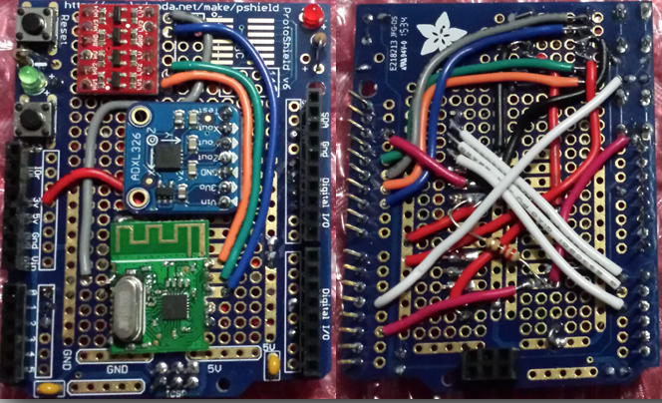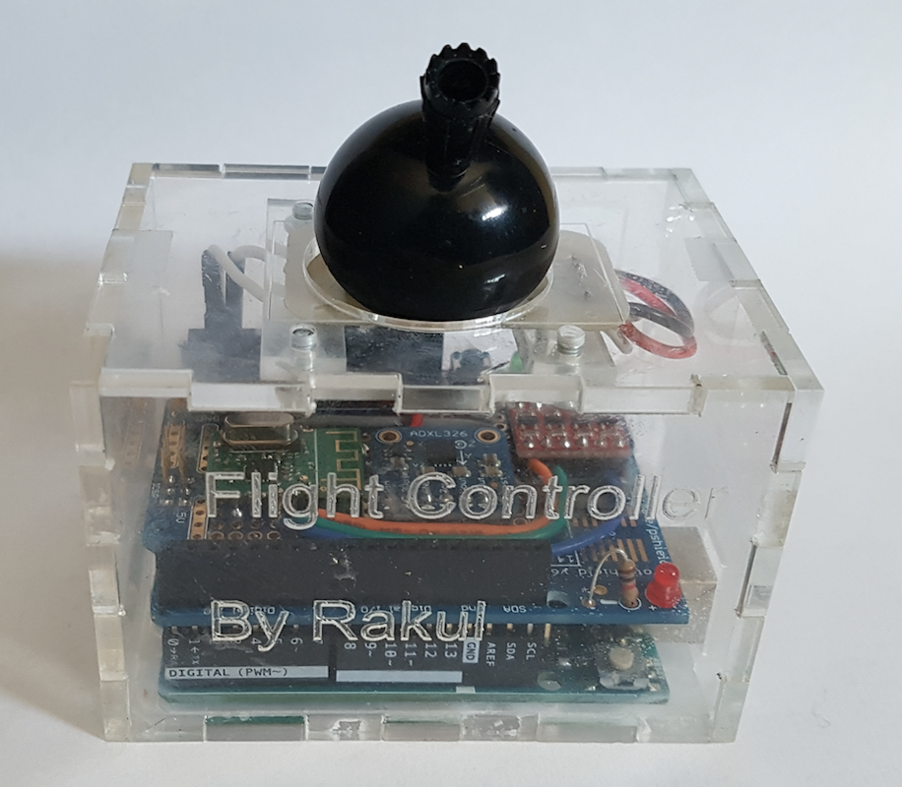

**Phase 6:** Connecting Camera Module to Hubsan

The final phase of the build focuses on connecting a small and light weight camera module to the drone. As shown in Figure 6.3, I also 3D printed a casing for the camera module so it would keep the module protected when the drone lands. The instructions to connect the module are shown below.

1. Remove the battery and the screws underneath the drone in order to remove the bottom of the shell
2. The drones circuit board will look similar to what is shown in Figure 6.1, the red circle on Figure 6.1 is where the connections are going to made. Take the female JST connector and solder the ground lead to the pin located to the left, in the circle. Connect the other end of the JST to the pin located to the right.
3. Reassemble the drone.
4. Desolder the GND and VCC on the camera module and solder male end of JST, as shown in Figure 6.2

Figure 6.1 Figure 6.2 Figure 6.3

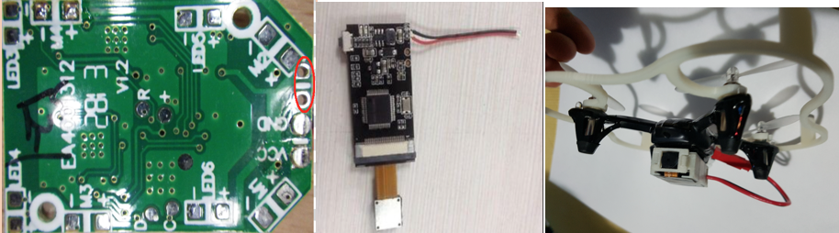

*2.2.2.5 PCB Soldering*

Throughout the course of the build we were encouraged to take advantage of the the recourses available from Humber College Institute of Technology, this includes Laser Cutting, 3D Printing and PCB Printing. I felt the connections on the joystick were not secure, so I decided to create a small PCB to mount the joystick (Figure 7). The PCB was designed using the Eagle software and printed with the assistance of Humber Lab Technician, Vlad.

Figure 7

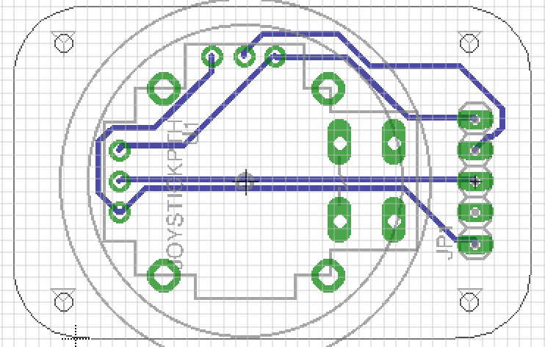

*2.2.2.6 Power Up*

Before powering hardware ensure all connections are correct and secure. Power on the Hubsan X4, the drone will have its LEDs flashing simultaneously. Now the Arduino can be powered on with the A7105 sketch uploaded to it. Upon powering the Arduino, the LEDs on the drone will blink twice and become solid. This identifies the drone has successfully bound to the hardware.

*2.2.2.7 Unit Testing*

The first test done was to ensure the drone’s binding sequence worked correctly. If the LEDs on the drone do not become solid upon powering the Arduino. It is likely the issue lies within the hardware itself. Double check all the connections and ensure all the pins on the A7105 are secure. The next test was to make sure all controls were functioning correctly. The following controls were tested for proper functionality:

* Vertical movement of the joystick controlled the drones throttle accordingly
* Horizontal movement of the joystick controlled the yaw of the drone accordingly
* Pressing the push button would calibrate the drones pitch and roll to the accelerometers current position. The LED will also light up when the button is pulled to low
* Tilting the hardware forward and backward with move the drone accordingly
* Tilting the hardware left and right will move the drone accordingly
* Insert micro SD card into camera module and test video recording

If any of the controls mentioned above presented improper functionality, the best solution would be too analog input connection each component was making. The value generated from each analog input can be tested using a print statement on the serial monitor. The values can be compared to what is expected in the source code (main.c) in order to determine the error.

*2.2.2.8 Production Testing*

For the final production testing the software component was implemented to the Hubsan’s flight controller hardware. The software component consists of an Android application, web interface and database. At this stage the hardware has the ability to control the drone independently, or control the drone and communicate runtime data using the android application. When using the built hardware with an android device the connection has to be made using a Serial cable and an OTG adapter. The following functionalities were tested for production testing:

1. Hardware functionality

* After the implementation of the software component, ensure the hardware’s independent functionality is unaffected (2.2.2.7 Unit Testing)

1. Android Application Functionality

* Applications login, register and guest works based on the data found in the database
* Throttle, yaw, roll and pitch function accordingly on the applications virtual joystick and demonstration mode
* Runtime data is sent and received correctly between the android application and web interface

1. Web Interface

* Web interfaces login, register and account management function accordingly to the data found in the database
* Displays correct user runtime data from the database

1. Database

* Ensure database records user data and user runtime information correctly

## 2.3 Feedback

### 2.3.1 Status updates feedback

#### 2.3.1.1 Status Report

This semester Rakul Mahenthiran and Rick Clapham have partnered up to complete the web, database and app component of the CENG capstone project. We both have two fully functional pieces of hardware which are capable of controlling either the Skywalker 1306 or Hubsan X4 micro drone. At the moment our goal is to have the web, database and app compatible with both flight controllers. We believe this is doable because the Arduino sketch for both flight controllers operate on an 8-bit resolution input.

#### 2.3.1.2 Status Report

The plan for the caged micro drone project is to record flight runtime information such as flight times, duration and battery life. Then display the data through our android application and web interface. The android application will also be capable of controlling the drone using Arduino to Android serial USB communication. Rick has created the database and wrote the php files so that the android application will be able to view the database's information. The Android device should be able to write to the database assuming it is connected to the internet. Rakul has managed to establish communication with the Arduino and the Android device and has made an application that controls the drone. Over the next few weeks we will be improving what we have and look into other things we can add to our project.

#### 2.3.1.3 Status Report

Both hardware’s are complete at the moment however, since we are aiming to use both Rakul has made a case and PCB to finish off his flight controller and Rick finished his hardware last semester. Rakul has added joysticks to our flight controller application and Rick has created a login and register php and a database for the application. At the moment we haven’t put any work into the web interface. For the technical report, we have put some work into the SRS component. We are on track and we will be completing the application soon and moving on to the web interface.

#### 2.3.1.4 Status Report

We have completed both hardware and modified them to be compatible with the android application. Rick has updated the Android application so that the user is able to login and register within the application as well as allow the user to view their runtime information which is specific to their account. Rick has also modified his Arduino code so that it is compatible with the Android application. Rakul has been modifying and updating the Android applications joysticks so that the application has a better response to the user’s commands and therefore making it easier to control. We will be starting on the web interface this week and it should allow the user to login, register and view their drone’s runtime information. Finally, we have updated the SRS component to include the sole authorship.

#### 2.3.1.5 Status Report

For our hardware, Rakul has added a module to provide filming capabilities. Rick has made a working login and sign up for our web interface. From our week 6 project demonstration, we have begun implementing some changes based on the feedback you gave. Rakul has begun implementing the demonstration mode for the flight controller application, in preparation for the open house. We also updated the References for our SRS based on the IEEE citation standards. Everything is on track and we will be figuring out how to implement the battery life this week.

#### 2.3.1.6 Status Report

Rick has successfully implemented the users flight time, flight duration and remaining battery life into the android application. As well as enabling the users run time information to be visible from the web interface. Rick has also created account modification features such as a password change and password recovery on the website. Rakul has finished the creation of the demonstration mode and we have implemented our Android applications together so that we have an updated application with everything included that we have created so far. Rakul is also working on updating his Arduino code so that the drone will either be controlled through the android application or the user made hardware.

#### 2.3.1.7 Status Report

We have pretty much achieved our goals with the project. Rick has added password encryption and account modification and recovery to the project. Rick has also modified his Arduino sketch to function with both the physical hardware controls and android application (This Arduino sketch is experimental and vulnerable to fault). Rakul has finished the UI for the android application. Our goal for the next few weeks is the technical report and looking for additional functionalities to improve the project.

### 2.3.2 Demonstration feedback

In week six of the semester we were asked to demonstrate our current project to our professor Kristian Medri. Kristian Medri recommended that we add a demonstration mode to our Android application to make explaining the project at the open house more efficient. This is also meant to assist in debugging the project if we were to encounter errors. The demonstration mode was then created by Rakul and implemented into the application in the following weeks.

### 2.3.3 Presentation feedback

In week thirteen of the semester we were asked to demonstrate our project to our professor Kristian Medri as well as our fellow classmates and peers. It was recommended by Kristian Medri that we make our future presentations more visually appealing as our presentation lacked diagrams and has too much information per slide. In the future our presentations will be more appealing to the audience.

## 2.4 As built

### 2.4.1 Hardware

As built the hardware to control either drone (Skywalker 1306 or Hubsan X4) is capable of communicating with the drone. The Skywalker 1306 hardware is capable of communicating directly with the drone using an Arduino and BK2421 transmitter and then use a serial cable to receive commands from the android application and then send the commands to the drone. Optionally, the user can create a microcontroller for the Skywalker 1306 in order to control the drone using physical joysticks. The hardware to control the Hubsan X4 is an Arduino and an A7105 wireless transceiver module. The Arduino will receive commands from the Android application and then send them to the Arduino using a serial cable; the Arduino will then be responsible for sending the commands to the Hubsan X4 micro drone. Optionally, you can control the Hubsan X4 using the physical hardware which is a joystick to control throttle and then an accelerometer to control the movement of the drone.

### 2.4.2 Database

As built the database is responsible for holding a user account and runtime information. The MySQL database uses a PHP front in order to connect with the Android application and web interface. The DroneMembers table is responsible for holding a list of all of the available members for our project. The table has three individual fields Username, Password and Email. The Username field contains the users name which is used when logging in. The Password field contains the users encrypted password which is used when logging in. Finally, the Email field is used for additional account security purposes this allows the user to recover their account if required. The DroneRuntime table is responsible for holding a list of all of the user’s runtime information. The table has five individual fields which are as follows User, Info, Time, Duration and ID. The Time field is an SQL timestamp that is recorded whenever the user sends information to the database. The duration field is a recording of the user’s total flight duration this is also used to display the drone’s battery life information. Finally, the remaining three fields are used to interpret and display the correct data.

### 2.4.3 Android Application

As built the Android application is responsible for allowing a user to control the micro drone of their choice. It is also capable of recording a user’s runtime information and allowing the user to view their personal runtime information. From the sign in menu the user can sign up, proceed as a guest or sign in as a full user. The signup simply allows the user to create an account with our project. The user sign allows the user to access the main menu which has three options: flight controller, demonstration mode and flight data. The guest sign in allows the user to enter the flight controller and demonstration modes however, the user is incapable of viewing runtime information. The flight controller is a duel joystick view that allows the user to control the drone in a user friendly way. If the user is signed in the flight controller will send information to the database about your flight time such as the start and end times. While the demonstration mode uses seek bars to control the drone’s movement this is used for debugging and demonstration purposes only. Finally, the flight information activity will connect to the database and then bring up a list view of all of the user’s personal flight information.

### 2.4.4 Web Interface

As built the web interface allows the user to sign up with our project and manage their account. The web interface is written with a mixture of PHP, HTML, CSS and Javascript. From the website the user is capable of registering with our project or signing in and viewing their runtime information. The website is also capable of allowing the user to change their password. The user is also capable of recovering their account if they have forgotten their password, in order to do this, they must have the email and username associated with their account and then a randomly generated password will be displayed on the html page. In conclusion the web interface is rather simple and handles only basic functionality such as account management and viewing their runtime information.

# Conclusion

In conclusion the caged micro drone project will meet all the requirements. We individually created our own separate hardware that is capable of communicating and controlling our individual drones. The MySQL database is capable of recording a user’s runtime information such as flight times and battery life as well as hold the users personal account information. The web component will allow the user to modify their accounts information such as their password and also allow the user to view their runtime information which is stored on the MySQL database. Finally, the android application will allow the user to control the when equipped with the appropriate hardware; the Android application will also handle updating the database with the user’s personal runtime information.

# Recommendations

Our recommendations for recreating the caged micro drone project is that you assemble and error test the hardware before attempting to establish database communication and attempting to use the android application. Simply create the hardware flight controller and attempt to control the drone just using the Arduino before attempting to use the android application. It is also highly recommended that you purchase additional transmitters no matter which hardware you purchase. In our experience the transmitters were incredibly frail and of all the hardware used were the most likely to break. Other recommendations would be to ensure that the drone works when you initially purchase otherwise it could lead to problems unit testing your hardware. The final recommendation is getting a designer to create a better casing for the hardware controller would allow a more comforting user experience when using the controller.

# Bibliography

[1] (2013, November 12). *Controlling toy quadcopter(s) with Arduino* [Online]. Available:

http://dzlsevilgeniuslair.blogspot.ca/2013/11/more-toy-quadcopter-hacking.html

[2] (2013, July 8). *Easy Android controllable, PC Interfaceable Relatively Cheap Mini Quadcopter (or*

*Octocopter!) Drone* [Online]. Available: http://www.instructables.com/id/Easy-Android-controllable-PC-Interfaceable-Relati/?ALLSTEPS

[3] Hariharan Mathavan (2015, October 16). *Communicate with Your Arduino Through Android* [Online].

Available: http://www.allaboutcircuits.com/projects/communicate-with-your-arduino-through-android/

[4] Jim ‘Ung (2015, April 10). *Reverse Engineering a Hubsan X4 Quadcopter* [Online]. Available:

http://www.jimhung.co.uk/?p=1349

[5] Ethan Ethnahs (2011, March 29). Mobile Anarchy Widgets [Online]. Available:

https://github.com/ethanhs/mobile-anarchy-widgets/tree/master/Widgets/src/com/ MobileAnarchy/Android/Widgets/Joystick

[6] Bill Earl (2015, May 04). Adafruit Analog Accelerometer Breakouts [Online]. Available:

https://learn.adafruit.com/adafruit-analog-accelerometer-breakouts/programming

[7]Ross, P.E. (20 February 2014). IEEE Xplore Digital Library [Online]. Available: <http://ieeexplore.ieee.org/xpl/articleDetails.jsp?arnumber=6745885&queryText=drone&subscribed=true&searchField=Search_All>

[8] Dierks, T. (31 December 2009). Dierks, T. Dept. of Electr. & Comput. Eng., Missouri Univ. of Sci. & Technol., Rolla, MO, USA | IEEE Xplore Digital Library [Online]. Available: <http://ieeexplore.ieee.org/xpl/articleDetails.jsp?arnumber=5345702&queryText=UAV&subscribed=true&searchField=Search_All>

[9]Dr. Gareth Owenson (January 2013). Google Code Archive [Online]. Available: <https://code.google.com/p/owenquad/>

[10]Ardupilot (Not sure of last update). Ardupilot sponsored by 3DRobotics [Online]. Available: <http://ardupilot.com/>

[11]Dronecode (Last updated 2015). Dronecode Project, Inc. Collaborates with 3DRobotics [Online] Available: <https://www.dronecode.org/>

[12]Magpi (December 2013). Magpi, Issue 19 [Online] Available: <http://people.ds.cam.ac.uk/mcj33/themagpi/The-MagPi-issue-19-en.pdf>

# Appendices

## Skywalker 1306 Arduino Sketch

The Arduino sketch used for the Skywalker 1306 is a modified version of the sketch and library created by dzievilgenius which is linked in the bibliography as [1]. The modifications I made were so that in place of reading in the values from an analog input the Arduino will receive the commands from the serial cable instead. The commands received using the serial cable are then inputted into the .update function which is then responsible for sending the data to the drone.

//************************************************************************

// HCD flying example

// (C) DZL December2013

//

// Inputs:

// Throttle analog 0

// Yaw analog 1

// Pitch analog 2

// Roll analog 3

//

//************************************************************************

#include <HCD.h>

int throttle = 0;

int yaw = 0;

int pitch = 0;

int roll = 0;

HCD drone0;

//Drone ID's (pick 4 random numbers)

unsigned char ID0[]={

0x16,0x01,0x55,0x11};

void setup()

{

Serial.begin(115200);

Serial.println("\n\nCommunication Starting...\n");

}

unsigned long timer=0;

void loop()

{

unsigned char c = '0';

switch(c)

{

case '0':

if(drone0.inactive())

drone0.bind(ID0);

break;

}

if(millis()>=timer)

{

if (Serial.available( )> 4){

if (Serial.read()!=23){

throttle = yaw = pitch = roll = 0;

}

else {

throttle=Serial.read();

yaw=Serial.read();

roll=Serial.read();

pitch=Serial.read();

yaw=255-yaw;

roll=255-roll;

}

}

timer+=20;

drone0.update(throttle,yaw,0x40,pitch,roll,0x40,0x40,0);

//Serial.print("Throttle:\t");

//Serial.println(analogRead(0)/4);

//Serial.print("Yaw:\t\t");

//Serial.println(analogRead(1)/4);

//Serial.print("Pitch:\t\t");

//Serial.println(analogRead(2)/4);

//Serial.print("Roll:\t\t");

//Serial.println(analogRead(3)/4);

}

}

## Hubsan X4 Arduino Sketch

The sketch I used for the Hubsan X4’s hardware is modified version of a sketch found on instructables[2]. The modifications I made are as follows:

1. In A7105.ino, enabling 4-wire SPI to allow full duplex communication between the drone and A7105 transceiver.

* In the method A7105_setup added the following line of code

A7105_WriteReg(0x0b, 0x19);

1. The main.c file provided in the instructable[2] did not work for me, so I made one that suited my needs for this project. The following source code allows me to generate the control values required for the packet to be sent to the drone. The code is capable of determining if the user would like to use the physical hardware controls or the android application, based on the positioning of the throttle joystick. Some of the code used in calibrating the accelerometer is referenced from Adafruit[6].

#define RES1 1023

#define RES2 32

#define AREF 255

int startTime;

double throttleVal, rudderVal;

int throttleInput, rudderInput;

int count = 0;

int xIn, yIn, zIn;

boolean calibrated = false;

int serialAvailable = 1;

//pins used

const int xInput = A0;

const int yInput = A1;

const int zInput = A2;

const int throttlePot = A3;

const int rudderPot = A4;

const int buttonPin = 2;

const int ledPin = 4;

// Accelerometer Raw Ranges:

// initialize to mid-range and allow calibration to

// find the minimum and maximum for each axis

int xRawMin = 512;

int xRawMax = 512;

int yRawMin = 512;

int yRawMax = 512;

int zRawMin = 512;

int zRawMax = 512;

// Accelerometer takes multiple samples to reduce noise

const int sampleSize = 10;

void setup() {

Serial.begin(115200);

A7105_Setup();

initialize();

startTime = micros();

pinMode(ledPin, OUTPUT);

pinMode(throttlePot, INPUT);

pinMode(rudderPot, INPUT);

analogReference(EXTERNAL);

throttle = rudder = aileron = elevator = 0;

digitalWrite(ledPin, LOW);

if(analogRead(throttlePot) == 0){

serialAvailable = 0;

}

}

void loop() {

//Serial.println(serialAvailable);

if(serialAvailable == 1) {

if (Serial.available( )> 4) {

if (Serial.read()!=23) {

throttle = rudder = aileron = elevator = 0;

} else {

throttle=Serial.read();

rudder=Serial.read();

aileron=Serial.read();

elevator=Serial.read();

}

}

}

if(serialAvailable == 0) {

throttleVal=analogRead(throttlePot);

throttleVal = (AREF*(throttleVal/RES1));

rudderVal=analogRead(rudderPot);

rudderVal = (AREF*(rudderVal/RES1));

rudderVal = 255 - rudderVal;

throttle=(byte)throttleVal;

rudder=(byte)rudderVal;

aileron=(byte)127;//x

elevator=(byte)127;//y

if (calibrated == true){

useAccelerometer();

}

if(digitalRead(buttonPin) == LOW){

calibrated = true;

}

}

int hubsanWait = hubsan_cb();

delayMicroseconds(hubsanWait);

}

void useAccelerometer(){

int xRaw = ReadAxis(xInput);

int yRaw = ReadAxis(yInput);

int zRaw = ReadAxis(zInput);

if (digitalRead(buttonPin) == LOW)

{

digitalWrite(ledPin, HIGH);

AutoCalibrate(xRaw, yRaw, zRaw);

}

else

{

digitalWrite(ledPin, LOW);

// Convert raw values to 'milli-Gs"

long xScaled = map(xRaw, xRawMin, xRawMax, -1000, 1000);

long yScaled = map(yRaw, yRawMin, yRawMax, -1000, 1000);

long zScaled = map(zRaw, zRawMin, zRawMax, -1000, 1000);

// re-scale to fractional Gs

float xAccel = xScaled / 1000.0;

float yAccel = yScaled / 1000.0;

float zAccel = zScaled / 1000.0;

//set limit to all axis 'G' range from -16 to 16

if(xAccel > 16.0){

xAccel = 16.0;

}

if(xAccel < (-16.0)){

xAccel = (-16.0);

}

if(yAccel > 16.0){

yAccel = 16.0;

}

if(yAccel < (-16.0)){

yAccel = (-16.0);

}

if(zAccel > 16.0){

zAccel = 16.0;

}

if(zAccel < (-16.0)){

zAccel = (-16.0);

}

//add 16 to all 'G' values to shift range to 0 to 32

xAccel = (xAccel * (-1)) + 16;

yAccel += 16;

zAccel += 16;

//modify the 0 to 32 range to 0 to 255 inorder to use as analog input for drone

xIn = AREF*(xAccel/RES2);

yIn = AREF*(yAccel/RES2);

zIn = AREF*(zAccel/RES2);

aileron=(byte)xIn;//x

elevator=(byte)yIn;//y

//Testing

//Serial.print("Your X and Y axis are set to: ");

//Serial.print(xIn);

//Serial.print(", ");

//Serial.println(yIn);

//Serial.print("Throttle and Rudder: ");

//Serial.print(throttleVal);

//Serial.print(" ,");

//Serial.println(rudderVal);

//Serial.println();

}

}

//

// Read "sampleSize" samples and report the average

//

int ReadAxis(int axisPin)

{

long reading = 0;

analogRead(axisPin);

delay(1);

for (int i = 0; i < sampleSize; i++)

{

reading += analogRead(axisPin);

}

return reading/sampleSize;

}

//

// Find the extreme raw readings from each axis

//

void AutoCalibrate(int xRaw, int yRaw, int zRaw)

{

//Serial.println("Calibrate");

if (xRaw < xRawMin)

{

xRawMin = xRaw;

}

if (xRaw > xRawMax)

{

xRawMax = xRaw;

}

if (yRaw < yRawMin)

{

yRawMin = yRaw;

}

if (yRaw > yRawMax)

{

yRawMax = yRaw;

}

if (zRaw < zRawMin)

{

zRawMin = zRaw;

}

if (zRaw > zRawMax)

{

zRawMax = zRaw;

}

}

## Android Application

### Login/ Register

* Connects to the database and allows the user to login to the android application or sign up with a new account.
* The signin.java creates an XML layout that allows the user to select an option as well as enter their username and password into edit text boxes. When the user presses the sign in button the java program will take the text entered in edit text boxes and pass them into an asynchronous task called SignInActivity.
* The SignInActivity will receive a username and password and then connect to a remote PHP file which is responsible for checking the entered usernmame and password against the database. If the username and password is correct the PHP file will return a success message to the Android application and will then successfully sign in the user.
* The signup activity functions similarly to the signin.java however it will receive in 4 fields which are email, username, password and password again. The signup activity will then pass it to an asynchronous task that will connect to a PHP file which will attempt to create the users account. If the users account is successfully created a success message will be sent back from the PHP file else if it is not successful, an error message will be sent back instead

#### Login activity

**package** com.example.rakul.hubsanflightcontroller;  
  
**import** android.app.AlertDialog;  
**import** android.app.ProgressDialog;  
**import** android.content.Context;  
**import** android.content.DialogInterface;  
**import** android.content.Intent;  
**import** android.content.SharedPreferences;  
**import** android.content.pm.ActivityInfo;  
**import** android.content.res.Configuration;  
**import** android.net.ConnectivityManager;  
**import** android.net.NetworkInfo;  
**import** android.os.AsyncTask;  
**import** android.os.Bundle;  
**import** android.support.v7.app.AppCompatActivity;  
**import** android.view.Menu;  
**import** android.view.MenuItem;  
**import** android.view.View;  
**import** android.view.inputmethod.InputMethodManager;  
**import** android.widget.Button;  
**import** android.widget.CheckBox;  
**import** android.widget.EditText;  
**import** android.widget.TextView;  
**import** android.widget.Toast;  
  
**import** org.apache.http.HttpResponse;  
**import** org.apache.http.client.HttpClient;  
**import** org.apache.http.client.methods.HttpGet;  
**import** org.apache.http.impl.client.DefaultHttpClient;  
  
**import** java.io.BufferedReader;  
**import** java.io.FileNotFoundException;  
**import** java.io.FileOutputStream;  
**import** java.io.IOException;  
**import** java.io.InputStreamReader;  
**import** java.net.URI;  
**import** java.net.URL;  
  
*/*  
 * @author: Richard Clapham  
 * @author: Rakul Mahenthiran  
 * @date: 4/8/2016  
 * Simple sign in user interface that allows tythe user to navigate to signup or guest vs  
 * regular user sign in. When the user presses sign in it will take their username and password  
 * and check it against the mySQL database if it is correct they will be signed in if not  
 * an error message will be displayed.  
 */***public class** SignIn **extends** AppCompatActivity  
{  
 **public final static** String ***SER_KEY*** = **"mycompany.myproject.ser"**;  
 **public final static** String ***SER_KEY2*** = **"mycompany.myproject.ser2"**;  
  
 **private** CheckBox **saveLoginCheckBox**;  
 **private** SharedPreferences **loginPreferences**;  
 **private** SharedPreferences.Editor **loginPrefsEditor**;  
 **private** Boolean **saveLogin**;  
 **private** EditText **UsernameEditText**;  
 **private** EditText **PasswordEditText**;  
 **private** Button **SignInButton**;  
 **private** Button **GuestButton**;  
 **private** TextView **signUpTextView**;  
 **private** String **myName**;  
 **private** String **myPassword**;  
  
 */*  
 * The main oncreate method applys on click listeners  
 */* @Override  
 **protected void** onCreate(Bundle savedInstanceState) {  
 **super**.onCreate(savedInstanceState);  
 setContentView(R.layout.***activity_sign_in***);  
  
 **UsernameEditText** = (EditText) findViewById(R.id.***editText***);  
 **PasswordEditText** = (EditText) findViewById(R.id.***editText3***);  
 **SignInButton** = (Button) findViewById(R.id.***button***);  
 **GuestButton** = (Button) findViewById(R.id.***button4***);  
 **signUpTextView** = (TextView) findViewById(R.id.***textView7***);  
 **saveLoginCheckBox** = (CheckBox)findViewById(R.id.***checkBox***);  
  
 **if** (isTablet()) {  
 setRequestedOrientation(ActivityInfo.***SCREEN_ORIENTATION_LANDSCAPE***);  
 }  
  
 **loginPreferences** = getSharedPreferences(**"loginPrefs"**, ***MODE_PRIVATE***);  
 **loginPrefsEditor** = **loginPreferences**.edit();  
  
 *//loads saved login information* **saveLogin** = **loginPreferences**.getBoolean(**"saveLogin"**, **false**);  
 **if** (**saveLogin**) {  
 **UsernameEditText**.setText(**loginPreferences**.getString(**"username"**, **""**));  
 **PasswordEditText**.setText(**loginPreferences**.getString(**"password"**, **""**));  
 **saveLoginCheckBox**.setChecked(**true**);  
 }  
  
 *///Checks to see if network is disabled if it is disables the main signin button* **if**(!isNetworkAvailable()){  
 **SignInButton**.setEnabled(**false**);  
 }  
  
 *//When the button is clicked will check to see if username and password is entered  
 //If username and password is entered checks for internet access again and if present  
 // will login online mode or if not it will disblay network connection lost* **SignInButton**.setOnClickListener(**new** View.OnClickListener() {  
 @Override  
 **public void** onClick(View v) {  
 **myName** = **UsernameEditText**.getText().toString().toLowerCase();  
 **myPassword** = **PasswordEditText**.getText().toString();  
 **if** (**myName**.length() > 0 && **myPassword**.length() > 0) {  
 InputMethodManager imm = (InputMethodManager) getSystemService(Context.***INPUT_METHOD_SERVICE***);  
 imm.hideSoftInputFromWindow(**UsernameEditText**.getWindowToken(), 0);  
  
 **if**(isNetworkAvailable()) {  
 **new** SignInActivity(getBaseContext(), 0).execute(**myName**, **myPassword**);  
 }  
 **else** {  
 Toast.*makeText*(SignIn.**this**, getResources().getString(R.string.***network***), Toast.***LENGTH_SHORT***).show();  
 **SignInButton**.setEnabled(**false**);  
 }  
  
 } **else** {  
 Toast.*makeText*(SignIn.**this**, getResources().getString(R.string.***incorrect3***), Toast.***LENGTH_SHORT***).show();  
 }  
 }  
 });  
  
 *//Allows the user to sign in as a guest in either online or offline mode* **GuestButton**.setOnClickListener(**new** View.OnClickListener() {  
 @Override  
 **public void** onClick(View v) {  
 createMyName(**"GUEST"**);  
 Intent myIntent = **new** Intent(SignIn.**this**, HomeScreen.**class**); *//Need to change to different activity* Bundle myBundle = **new** Bundle();  
 myIntent.putExtras(myBundle);  
 SignIn.**this**.startActivity(myIntent);  
 }  
 });  
  
 *//launches the signup activity* **signUpTextView**.setOnClickListener(**new** View.OnClickListener() {  
 @Override  
 **public void** onClick(View v) {  
 Intent myIntent = **new** Intent(SignIn.**this**, SignUp.**class**);  
 Bundle myBundle = **new** Bundle();  
 myIntent.putExtras(myBundle);  
 SignIn.**this**.startActivity(myIntent);  
 }  
 });  
 }  
  
 @Override  
 **public boolean** onCreateOptionsMenu(Menu menu) {  
 getMenuInflater().inflate(R.menu.***menu***, menu);  
 MenuItem item = menu.findItem(R.id.***logout_icon***);  
 item.setVisible(**false**);  
 **return super**.onCreateOptionsMenu(menu);  
 }  
  
 @Override  
 **public boolean** onOptionsItemSelected(MenuItem item) {  
 **switch** (item.getItemId()) {  
 **case** R.id.***help_icon***:  
 **new** AlertDialog.Builder(**this**)  
 .setTitle(**"Login Help"**)  
 .setMessage(**"Welcome to the Flight Controller Application!\n\n\n"** +  
 **"Existing User: If you have a user account please enter your login credentials to use the application.\n\n"** +  
 **"New User: If you are a new user, select sign-up or select login as guest."**)  
 .setPositiveButton(**"OK"**, **new** DialogInterface.OnClickListener() {  
 **public void** onClick(DialogInterface dialog, **int** which) {  
 *// continue with delete* }  
 })  
 .setIcon(getResources().getDrawable(R.drawable.***book***))  
 .show();  
 **return true**;  
 **case** R.id.***logout_icon***:  
 **return true**;  
 **default**:  
 **return super**.onOptionsItemSelected(item);  
 }  
 }  
  
 */*Creates a file holding the users personal information which is currently only the username  
 * @param String i recieves the username from the user and writes to file  
 */* **public void** createMyName(String i){  
 StringBuilder strFileContents = **new** StringBuilder(**""**);  
  
 String content = i;  
 strFileContents.append(content);  
 content = strFileContents.toString();  
 FileOutputStream fos = **null**;  
  
 **try** {  
 fos = openFileOutput(**"myUser.txt"**, ***MODE_PRIVATE***);  
 }  
 **catch** (FileNotFoundException e) {  
 *//* ***TODO Auto-generated catch block*** e.printStackTrace();  
 }  
 **try** {  
 fos.write(content.getBytes());  
 fos.close();  
 } **catch** (IOException e) {  
 *//* ***TODO Auto-generated catch block*** e.printStackTrace();  
 }  
 }  
  
 *//Checks if the device is a tablet returns true if it is* **private boolean** isTablet() {  
 **return** (**this**.getResources().getConfiguration().**screenLayout** & Configuration.***SCREENLAYOUT_SIZE_MASK***)  
 >= Configuration.***SCREENLAYOUT_SIZE_LARGE***;  
 }  
  
 */*Check if network is available  
 * @return boolean if network is avaialble returns true  
 */* **private boolean** isNetworkAvailable() {  
 ConnectivityManager connectivityManager  
 = (ConnectivityManager) getSystemService(Context.***CONNECTIVITY_SERVICE***);  
 NetworkInfo activeNetworkInfo = connectivityManager.getActiveNetworkInfo();  
 **return** activeNetworkInfo != **null** && activeNetworkInfo.isConnected();  
 }  
  
 */*  
 * Asynchronous task that will connect to the remote database and attempt log the user into  
 * the database  
 */* **private class** SignInActivity **extends** AsyncTask<String,Void,String>  
 {  
 **private** Context **context**;  
 **private int byGetOrPost** = 0;  
 **private** String **myCheck**= **""**;  
 ProgressDialog **builder**;  
  
 *//flag 0 means get and 1 means post.(By default it is get.)* **public** SignInActivity(Context context,**int** flag) {  
 **this**.**context** = context;  
 **byGetOrPost** = flag;  
 }  
  
 *//Disables signinbutton and guestloginbutton temporarily so the user cannot flood  
 // the database and enables a progressdialog so the user nkows the app is performing  
 //actions* **protected void** onPreExecute()  
 {  
 **SignInButton**.setEnabled(**false**);  
 **GuestButton**.setEnabled(**false**);  
 **builder** = **new** ProgressDialog(SignIn.**this**);  
 **builder**.setCancelable(**false**);  
 **builder**.setProgressStyle(ProgressDialog.***STYLE_SPINNER***);  
 **builder**.setTitle(getResources().getString(R.string.***signingIn***));  
 **builder**.setMessage(getResources().getString(R.string.***wait1***));  
 **builder**.show();  
 }  
  
 @Override  
 **protected** String doInBackground(String... arg0) {  
 **if**(**byGetOrPost** == 0){ *//means by Get Method* **try**{  
 String username = arg0[0];  
 String password = arg0[1];  
 String link = **"http://cengdrone.esy.es/DroneLogin.php?username="**+username+**"& password="**+password;  
 link = link.replaceAll(**" "**, **"%20"**);  
  
 URL url = **new** URL(link);  
 HttpClient client = **new** DefaultHttpClient();  
 HttpGet request = **new** HttpGet();  
 request.setURI(**new** URI(link));  
 HttpResponse response = client.execute(request);  
 BufferedReader in = **new** BufferedReader(**new** InputStreamReader(response.getEntity().getContent()));  
  
 StringBuffer sb = **new** StringBuffer(**""**);  
 String line=**""**;  
  
 **while** ((line = in.readLine()) != **null**) {  
 sb.append(line);  
 **break**;  
 }  
 in.close();  
 **myCheck** = sb.toString();  
 **return** sb.toString();  
 }  
  
 **catch**(Exception e){  
 **return "Exception: "** + e.getMessage();  
 }  
 }  
 **else**{**return "False"**;}  
 }  
  
 *//Checks to see if login was sucessful if it was logs the user into the app  
 // if you entered the wrong credentials a message will be displayed statign invalid username  
 // or password if your login was a sucess your credntials will be saved* @Override  
 **protected void** onPostExecute(String result){  
 **builder**.dismiss();  
 **SignInButton**.setEnabled(**true**);  
 **GuestButton**.setEnabled(**true**);  
 **if** (**myName**.equals(**myCheck**)){  
 **if** (**saveLoginCheckBox**.isChecked()) {  
 **loginPrefsEditor**.putBoolean(**"saveLogin"**, **true**);  
 **loginPrefsEditor**.putString(**"username"**, **myName**);  
 **loginPrefsEditor**.putString(**"password"**, **myPassword**);  
 **loginPrefsEditor**.apply();  
 } **else** {  
 **loginPrefsEditor**.clear();  
 **loginPrefsEditor**.apply();  
 }  
 createMyName(**myName**);  
 Toast.*makeText*(SignIn.**this**, getResources().getString(R.string.***loginS***), Toast.***LENGTH_SHORT***).show();  
 Intent myIntent = **new** Intent(SignIn.**this**, HomeScreen.**class**);  
 Bundle myBundle = **new** Bundle();  
 myIntent.putExtras(myBundle);  
 SignIn.**this**.startActivity(myIntent);  
 } **else** {Toast.*makeText*(SignIn.**this**, getResources().getString(R.string.***incorrect***), Toast.***LENGTH_SHORT***).show();}  
 }  
 }  
  
 @Override  
 **public void** onBackPressed() {  
 }  
}

#### Signup Activity

**package** com.example.rakul.hubsanflightcontroller;  
  
**import** android.app.AlertDialog;  
**import** android.app.ProgressDialog;  
**import** android.content.Context;  
**import** android.content.DialogInterface;  
**import** android.content.Intent;  
**import** android.content.pm.ActivityInfo;  
**import** android.content.res.Configuration;  
**import** android.net.ConnectivityManager;  
**import** android.net.NetworkInfo;  
**import** android.os.AsyncTask;  
**import** android.os.Bundle;  
**import** android.support.v7.app.AppCompatActivity;  
**import** android.view.Menu;  
**import** android.view.MenuItem;  
**import** android.view.View;  
**import** android.widget.Button;  
**import** android.widget.EditText;  
**import** android.widget.Toast;  
  
**import** org.apache.http.HttpResponse;  
**import** org.apache.http.client.HttpClient;  
**import** org.apache.http.client.methods.HttpGet;  
**import** org.apache.http.impl.client.DefaultHttpClient;  
  
**import** java.io.BufferedReader;  
**import** java.io.InputStreamReader;  
**import** java.net.URI;  
**import** java.net.URL;  
**import** java.util.concurrent.TimeUnit;  
  
*/*  
 * @author: Richard Clapham  
 * @author: Rakul Mahenthiran  
 * @date: 4/8/2016  
 * This is the SignUp screen it will allow the user to create an account with our application.  
 * Currently the account will hold their runtime information as well as allow for  
 * account recovery options through the web interface.  
 */***public class** SignUp **extends** AppCompatActivity {  
  
 **private** Button **SignUpButton**;  
 **private** String **myEmail**;  
 **private** String **myName**;  
 **private** String **myPassword**;  
 **private** String **myPasswordCheck**;  
 **private** EditText **EmailEditText**;  
 **private** EditText **UsernameEditText**;  
 **private** EditText **PasswordEditText**;  
 **private** EditText **cPasswordEditText**;  
  
 @Override  
 **protected void** onCreate(Bundle savedInstanceState) {  
 **super**.onCreate(savedInstanceState);  
 setContentView(R.layout.***activity_sign_up***);  
  
 **EmailEditText** = (EditText) findViewById(R.id.***editText2***);  
 **UsernameEditText** = (EditText) findViewById(R.id.***editText4***);  
 **PasswordEditText** = (EditText) findViewById(R.id.***editText5***);  
 **cPasswordEditText** = (EditText) findViewById(R.id.***editText6***);  
 **SignUpButton** = (Button) findViewById(R.id.***button5***);  
  
 **if** (isTablet()) {  
 setRequestedOrientation(ActivityInfo.***SCREEN_ORIENTATION_LANDSCAPE***);  
 }  
  
 *//checks if network is avaialble if it isnt disables the signup button* **if**(!isNetworkAvailable()){  
 **SignUpButton**.setEnabled(**false**);  
 }  
  
 *//When the signup button is clicked it will check the fields to make sure there is  
 //a valid email address username and password it will then check again to make sure that  
 //you have an internet connection and if you do it will create your account* **SignUpButton**.setOnClickListener(**new** View.OnClickListener() {  
 @Override  
 **public void** onClick(View v) {  
 **myEmail** = **EmailEditText**.getText().toString();  
 **myName** = **UsernameEditText**.getText().toString().toLowerCase();  
 **myPassword** = **PasswordEditText**.getText().toString();  
 **myPasswordCheck** = **cPasswordEditText**.getText().toString();  
  
 **if** (*isValidEmail*(**myEmail**)) {  
 **if** ((**myPassword**.length() > 0) && (**myName**.length() > 0)) {  
 **if** (**myName**.length() < 10){  
 **if** (**myPassword**.equals(**myPasswordCheck**)) {  
 AlertDialog.Builder builder = **new** AlertDialog.Builder(SignUp.**this**);  
 builder.setCancelable(**false**);  
 builder.setTitle(getResources().getString(R.string.***ConfirmS1***));  
 builder.setMessage(getResources().getString(R.string.***check2***));  
 builder.setPositiveButton(getResources().getString(R.string.***Confirm2***), **new** DialogInterface.OnClickListener() {  
 **public void** onClick(DialogInterface dialog, **int** id) {  
 *//connect to DB add Signup here* **if** (isNetworkAvailable()) {  
 **new** SignUpActivity(getBaseContext(), 0).execute(**myName**, **myPassword**, **myEmail**);  
 } **else** {  
 Toast.*makeText*(SignUp.**this**, getResources().getString(R.string.***network***), Toast.***LENGTH_SHORT***).show();  
 **SignUpButton**.setEnabled(**false**);  
 }  
 }  
 });  
 builder.setNegativeButton(getResources().getString(R.string.***Cancel1***), **new** DialogInterface.OnClickListener() {  
 **public void** onClick(DialogInterface dialog, **int** id) {  
 Toast.*makeText*(SignUp.**this**, getResources().getString(R.string.***CancelS2***), Toast.***LENGTH_SHORT***).show();  
 }  
 });  
 builder.show();  
 }**else**{Toast.*makeText*(SignUp.**this**, getResources().getString(R.string.***incorrect2***), Toast.***LENGTH_SHORT***).show();}  
 }**else**{Toast.*makeText*(SignUp.**this**, getResources().getString(R.string.***incorrect6***), Toast.***LENGTH_SHORT***).show();}  
 }**else**{Toast.*makeText*(SignUp.**this**, getResources().getString(R.string.***incorrect3***), Toast.***LENGTH_SHORT***).show();}  
 }**else**{Toast.*makeText*(SignUp.**this**, getResources().getString(R.string.***incorrect4***), Toast.***LENGTH_SHORT***).show();}  
 }  
 });  
 }  
  
 @Override  
 **public boolean** onCreateOptionsMenu(Menu menu) {  
 getMenuInflater().inflate(R.menu.***menu***, menu);  
 MenuItem item = menu.findItem(R.id.***logout_icon***);  
 item.setVisible(**false**);  
 **return super**.onCreateOptionsMenu(menu);  
 }  
  
  
 @Override  
 **public boolean** onOptionsItemSelected(MenuItem item) {  
 **switch** (item.getItemId()) {  
 **case** R.id.***help_icon***:  
 **new** AlertDialog.Builder(**this**)  
 .setTitle(**"Sign Up Help"**)  
 .setMessage(**"Welcome to the Flight Controller Application!\n\n\n"** +  
 **"Enter a Valid E-mail Address and unique username to associate with your account.\n\n"** +  
 **"Enter a password and retype the password in order to confirm then press Sign Up!\n\n"** +  
 **"For Account modification options please vist our website @ cengdrone.esy.es/index.html"** )  
 .setPositiveButton(**"OK"**, **new** DialogInterface.OnClickListener() {  
 **public void** onClick(DialogInterface dialog, **int** which) {  
 *// continue with delete* }  
 })  
 .setIcon(getResources().getDrawable(R.drawable.***book***))  
 .show();  
 **return true**;  
 **case** R.id.***logout_icon***:  
 **return true**;  
 **default**:  
 **return super**.onOptionsItemSelected(item);  
 }  
 }  
  
 *//Boolean that returns true if email is valid* **public final static boolean** isValidEmail(CharSequence target)  
 {  
 **if** (target == **null**) {  
 **return false**;  
 } **else** {  
 **return** android.util.Patterns.***EMAIL_ADDRESS***.matcher(target).matches();  
 }  
 }  
  
 *//Checks if the device is a tablet returns true if it is* **private boolean** isTablet() {  
 **return** (**this**.getResources().getConfiguration().**screenLayout** & Configuration.***SCREENLAYOUT_SIZE_MASK***)  
 >= Configuration.***SCREENLAYOUT_SIZE_LARGE***;  
 }  
  
 */*Check if network is available  
 * @return boolean if network is avaialble returns true  
 */* **private boolean** isNetworkAvailable() {  
 ConnectivityManager connectivityManager  
 = (ConnectivityManager) getSystemService(Context.***CONNECTIVITY_SERVICE***);  
 NetworkInfo activeNetworkInfo = connectivityManager.getActiveNetworkInfo();  
 **return** activeNetworkInfo != **null** && activeNetworkInfo.isConnected();  
 }  
  
 */*  
 SignUpActivity will take in your requested log in information and create an account based off  
 the requested information. The username needs to be unique and you will not be allowed to  
 create an account withe same username as another user  
 */* **private class** SignUpActivity **extends** AsyncTask<String,Void,String>  
 {  
 **private** Context **context**;  
 **private int byGetOrPost** = 0;  
 **private** String **myCheck** = **""**;  
 ProgressDialog **builder**;  
  
 *//flag 0 means get and 1 means post.(By default it is get.)* **public** SignUpActivity(Context context,**int** flag) {  
 **this**.**context** = context;  
 **byGetOrPost** = flag;  
 }  
  
 *//Disables signup button inorder to prevent the user from spamming the database  
 //And creates a progres dialog so the user know that an action is being performed* **protected void** onPreExecute()  
 {  
 **SignUpButton**.setEnabled(**false**);  
 **builder** = **new** ProgressDialog(SignUp.**this**);  
 **builder**.setCancelable(**false**);  
 **builder**.setProgressStyle(ProgressDialog.***STYLE_SPINNER***);  
 **builder**.setTitle(getResources().getString(R.string.***signingUp***));  
 **builder**.setMessage(getResources().getString(R.string.***wait0***));  
 **builder**.show();  
 }  
  
 *//Sends the users credentials to the server and creates an account* @Override  
 **protected** String doInBackground(String... arg0) {  
 **if**(**byGetOrPost** == 0){ *//means by Get Method* **try**{  
 String username = arg0[0];  
 String password = arg0[1];  
 String email = arg0[2];  
 String link = **"http://cengdrone.esy.es/DroneSignUp.php?username="**+username+**"& password="**+password+**"& email="**+email;  
 link = link.replaceAll(**" "**, **"%20"**);  
  
 URL url = **new** URL(link);  
 HttpClient client = **new** DefaultHttpClient();  
 HttpGet request = **new** HttpGet();  
 request.setURI(**new** URI(link));  
 HttpResponse response = client.execute(request);  
 BufferedReader in = **new** BufferedReader(**new** InputStreamReader(response.getEntity().getContent()));  
  
 StringBuffer sb = **new** StringBuffer(**""**);  
 String line=**""**;  
  
 **while** ((line = in.readLine()) != **null**) {  
 sb.append(line);  
 **break**;  
 }  
 in.close();  
 **myCheck** = sb.toString();  
 **return** sb.toString();  
 }  
 **catch**(Exception e){Toast.*makeText*(**context**, getResources().getString(R.string.***signupF***), Toast.***LENGTH_SHORT***).show(); **return new** String(**"Exception: "** + e.getMessage());}  
 }  
 **else**{Toast.*makeText*(**context**, getResources().getString(R.string.***signupF***), Toast.***LENGTH_SHORT***).show(); **return "False"**;}  
 }  
  
 *//Lets the user know if there registration was successful* @Override  
 **protected void** onPostExecute(String result){  
 **SignUpButton**.setEnabled(**true**);  
 **builder**.dismiss();  
 **if**(**myCheck**.equals(**"recordexists\t\t"**)){  
 Toast.*makeText*(**context**, getResources().getString(R.string.***signupF2***), Toast.***LENGTH_SHORT***).show();  
 }  
 **else** {  
 Toast.*makeText*(**context**, getResources().getString(R.string.***signupS***), Toast.***LENGTH_SHORT***).show();  
 Intent myIntent = **new** Intent(SignUp.**this**, SignIn.**class**);  
 Bundle myBundle = **new** Bundle();  
 myIntent.putExtras(myBundle);  
 SignUp.**this**.startActivity(myIntent);  
 }  
 }  
 }  
}

Flight Controller

– connects to Arduino and enables virtual joystick to fly drone

* FlightController.java uses the usbserial.jar [3] library to communicate with the Arduino
* The joysticks are a modified version of mobile anarchies widget code [5]

1. Modifying joystick properties to be suitable for drone in JoystickView.java

**private void** initJoystickView() {  
 setFocusable(**true**);  
  
 **dbgPaint1** = **new** Paint(Paint.***ANTI_ALIAS_FLAG***);  
 **dbgPaint1**.setColor(Color.***RED***);  
 **dbgPaint1**.setStrokeWidth(1);  
 **dbgPaint1**.setStyle(Paint.Style.***STROKE***);  
   
 **dbgPaint2** = **new** Paint(Paint.***ANTI_ALIAS_FLAG***);  
 **dbgPaint2**.setColor(Color.***GREEN***);  
 **dbgPaint2**.setStrokeWidth(1);  
 **dbgPaint2**.setStyle(Paint.Style.***STROKE***);  
   
 **bgPaint** = **new** Paint(Paint.***ANTI_ALIAS_FLAG***);  
 **bgPaint**.setColor(Color.***WHITE***);  
 **bgPaint**.setStrokeWidth(1);  
 **bgPaint**.setStyle(Paint.Style.***FILL_AND_STROKE***);  
  
 **handlePaint** = **new** Paint(Paint.***ANTI_ALIAS_FLAG***);  
 **handlePaint**.setColor(Color.***GRAY***);  
 **handlePaint**.setStrokeWidth(1);  
 **handlePaint**.setStyle(Paint.Style.***FILL_AND_STROKE***);  
  
 **innerPadding** = 10;  
   
 setMovementRange(128);  
 setMoveResolution(1.0f);  
 setClickThreshold(0.4f);  
 setYAxisInverted(**false**);  
 setUserCoordinateSystem(***COORDINATE_CARTESIAN***);  
 setAutoReturnToCenter(**true**);  
}

1. Modifying joystick to auto reset to 0 when throttle is removed JoystickView.java

**private void** lReturnHandleToCenter() {  
 **if** ( **autoReturnToCenter** ) {  
 **final int** numberOfFrames = 5;  
 **final double** intervalsX = (0 - **touchX**) / numberOfFrames;  
 **final double** intervalsY = (0 );  
  
 **for** (**int** i = 0; i < numberOfFrames; i++) {  
 **final int** j = i;  
 postDelayed(**new** Runnable() {  
 @Override  
 **public void** run() {  
 **touchX** += intervalsX;  
 **touchY** = **movementRadius** + **movementRadius** + **movementRadius**;  
 *//131;* reportOnMoved();  
 invalidate();  
  
 **if** (moveListener != **null** && j == numberOfFrames - 1) {  
 moveListener.OnReturnedToCenter();  
 }  
 }  
 }, i * 40);  
 }  
  
 **if** (moveListener != **null**) {  
 moveListener.OnReleased();  
 }  
 }  
}

1. Process user Joystick input in FlightCotroller.java

**private** JoystickMovedListener **_listenerLeft** = **new** JoystickMovedListener() {  
  
  
 @Override  
 **public void** OnMoved(**int** yaw, **int** throttle) {  
 **try** {  
 throttle = throttle + 128;  
 yaw = yaw + 128;  
 **if**(throttle >= 256)  
 throttle = 255;  
 **if**(yaw >= 256)  
 yaw = 255;  
 **if**(yaw >= 108 && yaw <= 148)  
 yaw = 127;  
  
 **txtX1**.setText(Integer.*toString*(throttle));  
 **txtY1**.setText(Integer.*toString*(yaw));  
 **input**[1] = (**byte**) throttle;  
 **input**[2] = (**byte**) yaw;  
 **serialPort**.write(**input**);  
 }**catch**(Exception e){  
 *//Toast.makeText(FlightController.this, "The Arduino Is Not Connected", Toast.LENGTH_SHORT).show();* }  
 }  
  
 @Override  
 **public void** OnReleased() {  
 **try**{  
  
 }**catch**(Exception e){  
 }  
  
 }  
  
 **public void** OnReturnedToCenter() {  
 **try**{  
  
 }**catch**(Exception e){  
 }  
 };  
};  
  
**private** JoystickMovedListener **_listenerRight** = **new** JoystickMovedListener() {  
  
 @Override  
 **public void** OnMoved(**int** pitch, **int** roll) {  
 **try**{  
 pitch = pitch + 128;  
 roll = roll + 128;  
 **if**(pitch >= 256)  
 pitch = 255;  
 **if**(pitch == 128)  
 pitch = 127;  
 **if**(roll >= 256)  
 roll = 255;  
 **if**(roll == 128)  
 roll = 127;  
  
 **txtX2**.setText(Integer.*toString*(pitch));  
 **txtY2**.setText(Integer.*toString*(roll));  
  
 **input**[3] = (**byte**) pitch;*//left or right* **input**[4] = (**byte**) roll;*//forward or backward* **serialPort**.write(**input**);  
 }**catch**(Exception e){  
 *//Toast.makeText(FlightController.this, "The Arduino Is Not Connected", Toast.LENGTH_SHORT).show();* }  
  
 }  
  
 @Override  
 **public void** OnReleased() {  
 **try**{  
  
 }**catch**(Exception e){  
 }  
 }  
  
 **public void** OnReturnedToCenter() {  
 **try**{  
  
 }**catch**(Exception e){  
 }  
  
 };  
};

Demo Mode

– connects to Arduino and enables a troubleshooting/ testing environment for the drone

* DemoMode.java uses the usbserial.jar [3] library to communicate with the Arduino
* The onCreate function with all control components is shown below:

@Override  
**protected void** onCreate(Bundle savedInstanceState) {  
 **super**.onCreate(savedInstanceState);  
 setContentView(R.layout.***activity_demo_mode***);  
  
 **myUserName** = readMyName();  
  
 **usbManager** = (UsbManager) getSystemService(**this**.***USB_SERVICE***);  
 **startButton** = (Button) findViewById(R.id.***buttonStart***);  
 **stopButton** = (Button) findViewById(R.id.***buttonStop***);  
 **textView** = (TextView) findViewById(R.id.***textView***);  
  
 **text1** = (TextView) findViewById(R.id.***t1***);  
 **text2** = (TextView) findViewById(R.id.***t2***);  
 **text3** = (TextView) findViewById(R.id.***t3***);  
 **text4** = (TextView) findViewById(R.id.***t4***);  
  
 **try** {  
 **throttleSlider** = (SeekBar) findViewById(R.id.***throttleSeekBar***);  
 **yawSlider** = (SeekBar) findViewById(R.id.***yawSeekBar***);  
 **pitchSlider** = (SeekBar) findViewById(R.id.***pitchSeekBar***);  
 **rollSlider** = (SeekBar) findViewById(R.id.***rollSeekBar***);  
 **throttleSlider**.setOnSeekBarChangeListener(**this**);  
 **yawSlider**.setOnSeekBarChangeListener(**this**);  
 **pitchSlider**.setOnSeekBarChangeListener(**this**);  
 **rollSlider**.setOnSeekBarChangeListener(**this**);  
  
 setUiEnabled(**false**);  
 IntentFilter filter = **new** IntentFilter();  
 filter.addAction(**ACTION_USB_PERMISSION**);  
 filter.addAction(UsbManager.***ACTION_USB_DEVICE_ATTACHED***);  
 filter.addAction(UsbManager.***ACTION_USB_DEVICE_DETACHED***);  
 registerReceiver(**broadcastReceiver**, filter);  
 }**catch**(Exception e){}  
}

* Code to read control input and send is shown below:

@Override  
**public void** onProgressChanged(SeekBar seekBar, **int** progress, **boolean** fromUser) {  
 **try** {  
 **switch** (seekBar.getId()) {  
 **case** R.id.***throttleSeekBar***:  
 **tempVal** = calculateSignal(progress);  
 **text1**.setText(**"Set Throttle: "** + **tempVal**);  
 **input**[1] = (**byte**) **tempVal**;  
 **serialPort**.write(**input**);  
 **break**;  
  
 **case** R.id.***yawSeekBar***:  
 **tempVal** = calculateSignal(progress);  
 **text2**.setText(**"Set Yaw: "** + **tempVal**);  
 **input**[2] = (**byte**) **tempVal**;  
 **serialPort**.write(**input**);  
 **break**;  
  
 **case** R.id.***rollSeekBar***:  
 **tempVal** = calculateSignal(progress);  
 **text3**.setText(**"Set Roll: "** + **tempVal**);  
 **input**[3] = (**byte**) **tempVal**;  
 **serialPort**.write(**input**);  
 **break**;  
  
 **case** R.id.***pitchSeekBar***:  
 **tempVal** = calculateSignal(progress);  
 **text4**.setText(**"Set Pitch: "** + **tempVal**);  
 **input**[4] = (**byte**) **tempVal**;  
 **serialPort**.write(**input**);  
 **break**;  
 }  
 }**catch**(Exception e){}  
}

Flight Data

- Displays Flight Data from database

* The flight data activity is broken up into 4 separate files which are as follows: FlightDataFile.java, FlightData.java, FlightDataAdapter.java and flight_data_view.xml.
* The FlightData.java is the main activity and is responsible for managing the other files. When the activity is entered it will call an asynchronous task that will connect to a PHP file which is responsible for returning a JSON array to the Android device. The asynchronous task will then interpret the data and display is using the aforementioned files.
* The FlightDataFile.java is an object file responsible for holding all of the information from the returned JSON array.
* The FlightDataAdapter.java and flight_data_view.xml are responsible for turning the FlightDataFile object into a listview that is easy for the user to read and manage.

#### FlightData Activity

**package** com.example.rakul.hubsanflightcontroller;  
  
**import** android.app.AlertDialog;  
**import** android.app.ProgressDialog;  
**import** android.content.Context;  
**import** android.content.DialogInterface;  
**import** android.content.Intent;  
**import** android.content.pm.ActivityInfo;  
**import** android.net.ConnectivityManager;  
**import** android.net.NetworkInfo;  
**import** android.os.AsyncTask;  
**import** android.support.v7.app.AppCompatActivity;  
**import** android.os.Bundle;  
**import** android.util.Log;  
**import** android.view.Menu;  
**import** android.view.MenuItem;  
**import** android.view.View;  
**import** android.widget.AdapterView;  
**import** android.widget.ListView;  
**import** android.widget.Toast;  
  
**import** org.apache.http.HttpEntity;  
**import** org.apache.http.HttpResponse;  
**import** org.apache.http.client.HttpClient;  
**import** org.apache.http.client.methods.HttpGet;  
**import** org.apache.http.impl.client.DefaultHttpClient;  
**import** org.apache.http.util.EntityUtils;  
**import** org.json.JSONArray;  
**import** org.json.JSONException;  
**import** org.json.JSONObject;  
  
**import** java.io.BufferedReader;  
**import** java.io.File;  
**import** java.io.FileReader;  
**import** java.io.IOException;  
**import** java.net.URI;  
**import** java.net.URL;  
**import** java.util.ArrayList;  
  
*/*  
* @author: Richard Clapham  
* @author: Rakul Mahenthiran  
* @date: 4/8/2016  
* This class is responsible for getting a user runtime information and then parsing it into an  
* array list which is then converted into a list view  
*/***public class** FlightData **extends** AppCompatActivity  
{  
 **private** ListView **myListView**;  
 **private** ArrayList<FlightDataFile> **myList**;  
 **private** String **myUserName**;  
  
 @Override  
 **protected void** onCreate(Bundle savedInstanceState) {  
 **super**.onCreate(savedInstanceState);  
 setContentView(R.layout.***activity_flight_data***);  
  
 **myList** = **new** ArrayList<>();  
 **myUserName** = readMyName();  
  
 **myListView** = (ListView) findViewById(R.id.***listView***);  
  
 *//Checks for internet connection and if it is available connects to the reote database  
 //Else it will use the local database* **if** (isNetworkAvailable()) {  
 **new** LoadFlightData(getBaseContext(), 0).execute();  
 } **else** {  
 Toast.*makeText*(FlightData.**this**,getResources().getString(R.string.***offline***), Toast.***LENGTH_LONG***).show();  
 }  
 }  
  
 @Override  
 **public boolean** onCreateOptionsMenu(Menu menu) {  
 getMenuInflater().inflate(R.menu.***menu***, menu);  
 **if**(readMyName().equals(**"GUEST"**)) {  
 MenuItem item = menu.findItem(R.id.***logout_icon***);  
 item.setVisible(**false**);  
 }  
 **return super**.onCreateOptionsMenu(menu);  
 }  
  
 @Override  
 **public boolean** onOptionsItemSelected(MenuItem item) {  
 **switch** (item.getItemId()) {  
 **case** R.id.***help_icon***:  
 **new** AlertDialog.Builder(**this**)  
 .setTitle(**"Flight Data Help"**)  
 .setMessage(**"Flight Data is displaying all the flights that took place under your account. For each flight, the start time, end time, duration and battery life are displayed."**)  
 .setPositiveButton(**"OK"**, **new** DialogInterface.OnClickListener() {  
 **public void** onClick(DialogInterface dialog, **int** which) {  
 *// continue with delete* }  
 })  
 .setIcon(getResources().getDrawable(R.drawable.***book***))  
 .show();  
 **return true**;  
 **case** R.id.***logout_icon***:  
 **new** AlertDialog.Builder(**this**)  
 .setTitle(**"Leaving Already!"**)  
 .setMessage(**"Are you sure you want to Logout?"**)  
 .setPositiveButton(**"Yes"**, **new** DialogInterface.OnClickListener() {  
 **public void** onClick(DialogInterface dialog, **int** which) {  
 Intent intent = **new** Intent(getApplicationContext(), SignIn.**class**);  
 startActivity(intent);  
 }  
 })  
 .setNegativeButton(**"No"**, **new** DialogInterface.OnClickListener() {  
 **public void** onClick(DialogInterface dialog, **int** which) {  
 }  
 })  
 .setIcon(getResources().getDrawable(R.drawable.***logout***))  
 .show();  
 **return true**;  
 **default**:  
 **return super**.onOptionsItemSelected(item);  
 }  
 }  
  
  
 **private boolean** isNetworkAvailable() {  
 ConnectivityManager connectivityManager  
 = (ConnectivityManager) getSystemService(Context.***CONNECTIVITY_SERVICE***);  
 NetworkInfo activeNetworkInfo = connectivityManager.getActiveNetworkInfo();  
 **return** activeNetworkInfo != **null** && activeNetworkInfo.isConnected();  
 }  
  
 **public** String readMyName()  
 {  
 File file = **new** File(getFilesDir(),**"myUser.txt"**);  
 StringBuilder text = **new** StringBuilder();  
  
 **try** {  
 BufferedReader buffReader = **new** BufferedReader(**new** FileReader(file));  
 String line;  
 **while** ((line = buffReader.readLine()) != **null**) {  
 text.append(line);  
 }  
 }  
 **catch** (IOException e) {  
 e.printStackTrace();  
 }  
 **finally**{}  
  
 **return** text.toString();  
 }  
  
 */*  
 * @author: Richard Clapham  
 * @author: Rakul Mahenthiran  
 * @date: 4/8/2016  
 * Sends an get request to the mySQL server that will ask for all the users data in the form of  
 * a JSON array. The json array will then be parsed into an object.  
 */* **private class** LoadFlightData **extends** AsyncTask<String, Void, String> {  
 **private** Context **context**;  
 **private int byGetOrPost** = 0;  
 JSONArray **stuff** = **null**;  
 **private static final** String ***TAG_JSONNAME*** = **"stuff"**;  
 **private static final** String ***TAG_USERNAME*** = **"User"**; *//edit these* **private static final** String ***TAG_INFO*** = **"Info"**;  
 **private static final** String ***TAG_TIME*** = **"Time"**;  
 **private static final** String ***TAG_DURATION*** = **"Duration"**;  
 ProgressDialog **builder**;  
  
 *//flag 0 means get and 1 means post.(By default it is get.)* **public** LoadFlightData(Context context, **int** flag) {  
 **this**.**context** = context;  
 **byGetOrPost** = flag;  
 }  
  
 *//Creates a progressdialog so the user knows the app is performing actions.* **protected void** onPreExecute() {  
 **builder** = **new** ProgressDialog(FlightData.**this**);  
 **builder**.setCancelable(**false**);  
 **builder**.setProgressStyle(ProgressDialog.***STYLE_SPINNER***);  
 **builder**.setTitle(getResources().getString(R.string.***loading***));  
 **builder**.setMessage(getResources().getString(R.string.***wait2***));  
 **builder**.show();  
 }  
  
 *//Connects to database and recieves a JSONArray* @Override  
 **protected** String doInBackground(String... arg0) {  
 **if** (**byGetOrPost** == 0) { *//means by Get Method* **try** {  
 String link = **"http://cengdrone.esy.es/DroneData.php?username="**+**myUserName**;  
 link = link.replaceAll(**" "**, **"%20"**);  
  
 URL url = **new** URL(link);  
 HttpClient client = **new** DefaultHttpClient();  
 HttpGet request = **new** HttpGet();  
 request.setURI(**new** URI(link));  
 HttpResponse response = client.execute(request);  
 HttpEntity httpEntity = response.getEntity();  
 String myResponse = EntityUtils.toString(httpEntity);  
  
 *// Making a request to url and getting response* Log.d(**"Response: "**, **"> "** + myResponse);  
  
 **if** (myResponse != **null**) {  
 **try** {  
 JSONObject jsonObj = **new** JSONObject(myResponse);  
 *// Getting JSON Array node* stuff = jsonObj.getJSONArray(TAG_JSONNAME);  
 } **catch** (JSONException e) {  
 e.printStackTrace();  
 }  
 } **else** {  
 Log.e(**"ServiceHandler"**, **"Couldn't get any data from the url"**);  
 }  
 **return null**;  
 } **catch** (Exception e) {  
 **return "Exception: "** + e.getMessage();  
 }  
 } **else** {  
 **return "False"**;  
 }  
 }  
  
 *//Iterates through the data gathered from the return string and displays it.* @Override  
 **protected void** onPostExecute(String result) {  
 builder.dismiss();  
 **try** {  
 **int** x = 0;  
 **if**(stuff.length()%2==0){x = 0;}**else**{x = 1;}  
 *// looping through All Contacts* **for** (**int** i = x; i < stuff.length(); i++) {  
 FlightDataFile myTemp = **new** FlightDataFile();  
  
 JSONObject c = stuff.getJSONObject(i);  
  
 String tempUserName1 = c.getString(TAG_USERNAME);  
 String tempInfo1 = c.getString(TAG_INFO);  
 String tempTime1 = c.getString(TAG_TIME);  
 String tempDuration1 = c.getString(TAG_DURATION);  
  
 myTemp.setUsername1(tempUserName1);  
 myTemp.setInfo1(tempInfo1);  
 myTemp.setTime1(tempTime1);  
 myTemp.setDuration1(tempDuration1);  
  
 i = i + 1;  
 JSONObject d = stuff.getJSONObject(i);  
  
 String tempUserName2 = d.getString(TAG_USERNAME);  
 String tempInfo2 = d.getString(TAG_INFO);  
 String tempTime2 = d.getString(TAG_TIME);  
 String tempDuration2 = d.getString(TAG_DURATION);  
  
 myTemp.setUsername2(tempUserName2);  
 myTemp.setInfo2(tempInfo2);  
 myTemp.setTime2(tempTime2);  
 myTemp.setDuration2(tempDuration2);  
  
 myList.add(myTemp);  
 }  
 myListView.setEmptyView(findViewById(R.id.empty_list_item));  
 FlightDataAdapter arrayAdapter = **new** FlightDataAdapter(FlightData.**this**, R.layout.flight_data_view, myList);  
 myListView.setAdapter(arrayAdapter);  
 } **catch** (JSONException e) {  
 e.printStackTrace();  
 }  
 }  
 }  
}

#### FlightDataFile java object

**package** com.example.rakul.hubsanflightcontroller;  
  
**import** android.support.v7.app.AppCompatActivity;  
  
**import** java.io.Serializable;  
  
*/*  
* @author: Richard Clapham  
* @author: Rakul Mahenthiran  
* @date: 4/8/2016  
* Object file used to store the drones runtime information before it is parsed into the listview  
*/***public class** FlightDataFile **extends** AppCompatActivity **implements** Serializable  
{  
 **private static final long *serialVersionUID*** = -7060210544600464481L;  
 **private** String **Time1**;  
 **private** String **Info1**;  
 **private** String **Username1**;  
 **private** String **Duration1**;  
 **private** String **Time2**;  
 **private** String **Info2**;  
 **private** String **Username2**;  
 **private** String **Duration2**;  
 **private int BatteryLife**;  
  
 *//Default Constructor* **public** FlightDataFile() {  
 **this**.**Time1** = **""**;  
 **this**.**Info1** = **""**;  
 **this**.**Username1** = **""**;  
 **this**.**Duration1** = **""**;  
 **this**.**Time2** = **""**;  
 **this**.**Info2** = **""**;  
 **this**.**Username2** = **""**;  
 **this**.**Duration2** = **""**;  
 **this**.**BatteryLife** = 0;  
 }  
  
 *//My Setters* **public void** setTime1(String i){**Time1** = i;}  
 **public void** setInfo1(String i){**Info1** = i;}  
 **public void** setUsername1(String i){**Username1** = i;}  
 **public void** setDuration1(String i){**Duration1** = i;}  
  
 **public void** setTime2(String i){**Time2** = i;}  
 **public void** setInfo2(String i){**Info2** = i;}  
 **public void** setUsername2(String i){**Username2** = i;}  
 **public void** setDuration2(String i){**Duration2** = i;}  
  
 **public void** setBatteryLife(**int** i){**BatteryLife** = i;}  
  
 *//My Getters* **public** String getTime1(){**return Time1**;}  
 **public** String getInfo1(){**return Info1**;}  
 **public** String getUsername1(){**return Username1**;}  
 **public** String getDuration1(){**return Duration1**;}  
  
 **public** String getTime2(){**return Time2**;}  
 **public** String getInfo2(){**return Info2**;}  
 **public** String getUsername2(){**return Username2**;}  
 **public** String getDuration2(){**return Duration2**;}  
  
 **public int** getBatteryLife(){**return BatteryLife**;}  
}

#### FlightDataAdapter.java

**package** com.example.rakul.hubsanflightcontroller;  
  
**import** android.content.Context;  
**import** android.view.LayoutInflater;  
**import** android.view.View;  
**import** android.view.ViewGroup;  
**import** android.widget.ArrayAdapter;  
**import** android.widget.TextView;  
  
**import** java.text.DecimalFormat;  
**import** java.util.ArrayList;  
  
*/*  
* @author: Richard Clapham  
* @author: Rakul Mahenthiran  
* @date: 4/8/2016  
* Responsible for receiving an object of flightdatafile. This will take the onject and parse the  
* data so that it is comparable with a listview.  
*/***public class** FlightDataAdapter **extends** ArrayAdapter<FlightDataFile>  
{  
 **private** ArrayList<FlightDataFile> **objects**;  
  
 **public** FlightDataAdapter(Context context, **int** textViewResourceId, ArrayList<FlightDataFile> objects)  
 {  
 **super**(context, textViewResourceId, objects);  
 **this**.**objects** = objects;  
 }  
  
 **public** View getView(**int** position, View convertView, ViewGroup parent)  
 {  
  
 View v = convertView;  
  
 **if** (v == **null**) {  
 LayoutInflater inflater = (LayoutInflater) getContext().getSystemService(Context.***LAYOUT_INFLATER_SERVICE***);  
 v = inflater.inflate(R.layout.***flight_data_view***, **null**);  
 }  
  
 FlightDataFile i = **objects**.get(position);  
  
 *//Checks if object isn't null and if it isnt loads the data into the listview* **if** (i != **null**) {  
  
 *// This is how you obtain a reference to the TextViews.  
 // These TextViews are created in the XML files we defined.* TextView t1 = (TextView) v.findViewById(R.id.***textView5***);  
 TextView t2 = (TextView) v.findViewById(R.id.***textView6***);  
 TextView t3 = (TextView) v.findViewById(R.id.***textView8***);  
 TextView t4 = (TextView) v.findViewById(R.id.***textView9***);  
  
 **try** {  
 **if** (t1 != **null**) {  
 t1.setText(i.getTime1());  
 }  
 **if** (t2 != **null**) {  
 t2.setText(i.getTime2());  
 }  
 **if** (t3 != **null**) {  
 t3.setText(i.getDuration2()+**"s"**);  
 }  
 **if** (t4 != **null**) {  
 String myDuration = i.getDuration2();  
 **double** myDurationDouble = Double.*parseDouble*(myDuration);  
 **double** myBatteryLife = (myDurationDouble/480) * 100;  
 myBatteryLife = 100 - myBatteryLife;  
 DecimalFormat df = **new** DecimalFormat(**"#.##"**);  
 myBatteryLife = Double.*valueOf*(df.format(myBatteryLife));  
 t4.setText(**"Approximent Battery Life:\t"**+myBatteryLife+**"%"**);  
 **if**(myBatteryLife < 0)  
 t4.setText(**"Approximent Battery Life:\t0.00%"**);  
 }  
 }**catch**(Exception e){}  
  
 }  
 *// the view must be returned to our activity* **return** v;  
 }  
}

#### flight_data_view.xml

*<?***xml version="1.0" encoding="utf-8"***?>*<**RelativeLayout xmlns:android="http://schemas.android.com/apk/res/android"  
 android:layout_width="match_parent" android:layout_height="match_parent"  
 android:background="@drawable/rounded_corner"**>  
  
 <**TextView  
 android:layout_width="wrap_content"  
 android:layout_height="wrap_content"  
 android:textAppearance="?android:attr/textAppearanceMedium"  
 android:text="@string/FST"  
 android:id="@+id/textView2"  
 android:layout_alignParentTop="true"  
 android:layout_alignParentStart="true"  
 android:textColor="@color/black"**/>  
  
 <**TextView  
 android:layout_width="wrap_content"  
 android:layout_height="wrap_content"  
 android:textAppearance="?android:attr/textAppearanceMedium"  
 android:text="@string/FET"  
 android:id="@+id/textView3"  
 android:layout_below="@+id/textView2"  
 android:layout_alignParentStart="true"  
 android:textColor="@color/black"**/>  
  
 <**TextView  
 android:layout_width="wrap_content"  
 android:layout_height="wrap_content"  
 android:textAppearance="?android:attr/textAppearanceMedium"  
 android:text="@string/FD"  
 android:id="@+id/textView4"  
 android:layout_below="@+id/textView3"  
 android:layout_alignParentStart="true"  
 android:textColor="@color/black"**/>  
  
 <**TextView  
 android:layout_width="wrap_content"  
 android:layout_height="wrap_content"  
 android:textAppearance="?android:attr/textAppearanceMedium"  
 android:text="N/A"  
 android:id="@+id/textView5"  
 android:layout_alignParentTop="true"  
 android:layout_alignParentEnd="true"  
 android:textColor="@color/black"**/>  
  
 <**TextView  
 android:layout_width="wrap_content"  
 android:layout_height="wrap_content"  
 android:textAppearance="?android:attr/textAppearanceMedium"  
 android:text="N/A"  
 android:id="@+id/textView6"  
 android:layout_below="@+id/textView5"  
 android:layout_alignParentEnd="true"  
 android:textColor="@color/black"**/>  
  
 <**TextView  
 android:layout_width="wrap_content"  
 android:layout_height="wrap_content"  
 android:textAppearance="?android:attr/textAppearanceMedium"  
 android:text="N/A"  
 android:id="@+id/textView8"  
 android:layout_below="@+id/textView6"  
 android:layout_alignParentEnd="true"  
 android:textColor="@color/black"**/>  
  
 <**TextView  
 android:layout_width="wrap_content"  
 android:layout_height="wrap_content"  
 android:textAppearance="?android:attr/textAppearanceMedium"  
 android:text="N/A"  
 android:id="@+id/textView9"  
 android:layout_below="@+id/textView4"  
 android:layout_alignParentStart="true"  
 android:textColor="@color/black"**/>  
</**RelativeLayout**>

## Web Interface

* The web interface is a simple user interface that allows the user to manage their account and view their flight information. It uses both PHP and HTML elements to program and design the webpage. We will not be including the javascript, CSS or Ruby elements that we used as we did not originally create them. The creator of the design of the template used was Boris Borisov and the initial CSS, Javascript and Ruby files were created by Andy Tran.
  + Index.html is the main webpage that the website will direct you to and it allows the user to sign in and register with our database
  + The changepass.html allows the user to manage their account. It performs such features as change their password and recover their account if they have forgotten their password.
  + The error.html pages are simply error messages that are called on by certain PHP files if there is an error such as invalid sign in credentials.
  + Finally, the userinfo.php is a PHP file that echos and HTML page and will display the logged in users account specific information.

### Website Home Page -Index.html

<?php

session_start();

session_destroy();

?>

<!DOCTYPE html>

<html >

<head>

<meta charset="UTF-8">

<title>CENG Caged Micro Drone</title>

<link rel="stylesheet" href="css/reset.css">

<link rel='stylesheet prefetch' href='http://fonts.googleapis.com/css?family=Roboto:400,100,300,500,700,900|RobotoDraft:400,100,300,500,700,900'>

<link rel='stylesheet prefetch' href='http://maxcdn.bootstrapcdn.com/font-awesome/4.3.0/css/font-awesome.min.css'>

<link rel="stylesheet" href="css/style.css">

</head>

<body>

<!-- Mixins-->

<!-- Pen Title-->

<div class="pen-title"><h1>Caged Micro Drone</h1></div>

<div class="container"><div class="card"></div>

<div class="card">

<h1 class="title">Login / Register --></h1>

<form name="form1" method="post" action="checklogin.php">

<div class="input-container">

<input type="text" name="myusername" id="Username" required="required"/>

<label for="Username">Username</label>

<div class="bar"></div>

</div>

<div class="input-container">

<input type="password" name="mypassword" id="Password" required="required"/>

<label for="Password">Password</label>

<div class="bar"></div>

</div>

<div class="button-container">

<button><span>Go</span></button>

</div>

<div class="footer"><a href="http://cengdrone.esy.es/changepass.html">Change your password?</a></div>

</form>

</div>

<div class="card alt">

<div class="toggle"></div>

<h1 class="title">Register<div class="close"></div></h1>

<form name="form2" method="post" action="checkregister.php">

<div class="input-container">

<input type="text" name="myemail" id="Email" required="required"/>

<label for="Email">Email</label>

<div class="bar"></div>

</div>

<div class="input-container">

<input type="text" name="myusername" id="Username" required="required"/>

<label for="Username">Username</label>

<div class="bar"></div>

</div>

<div class="input-container">

<input type="password" name="mypassword" id="Password" required="required"/>

<label for="Password">Password</label>

<div class="bar"></div>

</div>

<div class="input-container">

<input type="password" name="mypassword2" id="Repeat Password" required="required"/>

<label for="Repeat Password">Re-Type Password</label>

<div class="bar"></div>

</div>

<div class="button-container">

<button><span>Next</span></button>

</div>

</form>

</div>

</div>

<script src='http://cdnjs.cloudflare.com/ajax/libs/jquery/2.1.3/jquery.min.js'></script>

<script src="js/index.js"></script>

</body>

</html>

### Website Manage Account Page -changepass.html

<?php

session_start();

session_destroy();

?>

<!DOCTYPE html>

<html >

<head>

<meta charset="UTF-8">

<title>CENG Caged Micro Drone</title>

<link rel="stylesheet" href="css/reset.css">

<link rel='stylesheet prefetch' href='http://fonts.googleapis.com/css?family=Roboto:400,100,300,500,700,900|RobotoDraft:400,100,300,500,700,900'>

<link rel='stylesheet prefetch' href='http://maxcdn.bootstrapcdn.com/font-awesome/4.3.0/css/font-awesome.min.css'>

<link rel="stylesheet" href="css/style.css">

</head>

<body>

<!-- Mixins-->

<!-- Pen Title-->

<div class="pen-title"><h1>Caged Micro Drone</h1></div>

<div class="container"><div class="card"></div>

<div class="card">

<h1 class="title">Change Password?</h1>

<form name="form3" method="post" action="changepassword.php">

<div class="input-container">

<input type="text" name="myusername" id="Username" required="required"/>

<label for="Username">Username</label>

<div class="bar"></div>

</div>

<div class="input-container">

<input type="password" name="mypassword" id="Password" required="required"/>

<label for="Password">Old Password</label>

<div class="bar"></div>

</div>

<div class="input-container">

<input type="password" name="mypassword2" id="Password2" required="required"/>

<label for="Repeat Password">New Password</label>

<div class="bar"></div>

</div>

<div class="button-container">

<button><span>Next</span></button>

</div>

</form>

</div>

<div class="card alt">

<div class="toggle"></div>

<h1 class="title">Forgot Password?<div class="close"></div></h1>

<form name="form4" method="post" action="forgotpassword.php">

<div class="input-container">

<input type="text" name="myemail" id="Email" required="required"/>

<label for="Email">E-Mail Address</label>

<div class="bar"></div>

</div>

<div class="input-container">

<input type="text" name="myusername" id="Username" required="required"/>

<label for="Username">Username</label>

<div class="bar"></div>

</div>

<div class="button-container">

<button><span>Receive New Password?</span></button>

</div>

</form>

</div>

</div>

<script src='http://cdnjs.cloudflare.com/ajax/libs/jquery/2.1.3/jquery.min.js'></script>

<script src="js/index.js"></script>

</body>

</html>

### Website display runtime information -userinfo.php

<?php

session_start();

?>

<?php

$DB_HOST = "mysql.hostinger.co.uk";

$DB_UNAME = "";

$DB_PWD = "";

$DB_DATABASE = "";

/* Connecting to mysql database */

$con = mysqli_connect($DB_HOST, $DB_UNAME, $DB_PWD, $DB_DATABASE);

if (mysqli_connect_errno()) {

header("location:error4.html");

}

$myusername= $_SESSION['myusername'];

$result = mysqli_query($con, "SELECT User,Info,Time,ID,Duration FROM DroneRuntime Where User = '$myusername' ORDER BY ID DESC LIMIT 20");

echo "

<html >

<head>

<meta charset=\"UTF-8\">

<title>CENG Caged Micro Drone</title>

<link rel=\"stylesheet\" href=\"css/reset.css\">

<link rel='stylesheet prefetch' href='http://fonts.googleapis.com/css?family=Roboto:400,100,300,500,700,900|RobotoDraft:400,100,300,500,700,900'>

<link rel='stylesheet prefetch' href='http://maxcdn.bootstrapcdn.com/font-awesome/4.3.0/css/font-awesome.min.css'>

<link rel=\"stylesheet\" href=\"css/style.css\">

</head>

<body>

<div class=\"pen-title\"><h1>Caged Micro Drone</h1></div>

<div class=\"container\"><div class=\"card\"></div>

<div class=\"card\">

<table border='3' cellpadding='5' cellspacing='5' bordercolor=\"black\" width=\"100%\">

<tr>

<th>Username</th>

<th>Information</th>

<th>Time</th>

<th>Duration</th>

<th>Battery Life</th>

</tr>";

while($row = mysqli_fetch_array($result))

{

echo "<tr>";

echo "<td align=\"center\">" . $row['User'] . "</td>";

echo "<td align=\"center\">" . $row['Info'] . "</td>";

echo "<td align=\"center\">" . $row['Time'] . "</td>";

echo "<td align=\"center\">" . $row['Duration'] . "</td>";

$BL = $row['Duration'];

$BL = $BL/480 * 100;

$BL = 100 - $BL;

if($BL < 0){

$BL = 0;

}

echo "<td align=\"center\">" . round($BL, 2) . "%</td>";

echo "</tr>";

}

echo "

</div>

<script src='http://cdnjs.cloudflare.com/ajax/libs/jquery/2.1.3/jquery.min.js'></script>

<script src=\"js/index.js\"></script>

</body>

</html>";

mysqli_close($con);

?>

### Website Session Check -login_success.php

############### Code

// Check if session is not registered, redirect back to main page.

// Put this code in first line of web page.

<?php

session_start();

{

header("location:userinfo.php");

}

?>

<html>

<body>

Login Successful

</body>

</html>

### Website Error 1 -error1.html

<!DOCTYPE html>

<html >

<head>

<meta charset="UTF-8">

<title>CENG Caged Micro Drone</title>

<link rel="stylesheet" href="css/reset.css">

<link rel='stylesheet prefetch' href='http://fonts.googleapis.com/css?family=Roboto:400,100,300,500,700,900|RobotoDraft:400,100,300,500,700,900'>

<link rel='stylesheet prefetch' href='http://maxcdn.bootstrapcdn.com/font-awesome/4.3.0/css/font-awesome.min.css'>

<link rel="stylesheet" href="css/style.css">

</head>

<body>

<!-- Mixins-->

<!-- Pen Title-->

<div class="pen-title"><h1>Caged Micro Drone</h1></div>

<div class="container"><div class="card"></div>

<div class="card">

<h1 class="title">Incorrect Username or Password!</h1>

</div>

<script src='http://cdnjs.cloudflare.com/ajax/libs/jquery/2.1.3/jquery.min.js'></script>

<script src="js/index.js"></script>

</body>

</html>

### Website Error 2 -error2.html

<!DOCTYPE html>

<html >

<head>

<meta charset="UTF-8">

<title>CENG Caged Micro Drone</title>

<link rel="stylesheet" href="css/reset.css">

<link rel='stylesheet prefetch' href='http://fonts.googleapis.com/css?family=Roboto:400,100,300,500,700,900|RobotoDraft:400,100,300,500,700,900'>

<link rel='stylesheet prefetch' href='http://maxcdn.bootstrapcdn.com/font-awesome/4.3.0/css/font-awesome.min.css'>

<link rel="stylesheet" href="css/style.css">

</head>

<body>

<!-- Mixins-->

<!-- Pen Title-->

<div class="pen-title"><h1>Caged Micro Drone</h1></div>

<div class="container"><div class="card"></div>

<div class="card">

<h1 class="title">Passwords Do Not Match!</h1>

</div>

<script src='http://cdnjs.cloudflare.com/ajax/libs/jquery/2.1.3/jquery.min.js'></script>

<script src="js/index.js"></script>

</body>

</html>

### Website Error 3 -error3.html

<!DOCTYPE html>

<html >

<head>

<meta charset="UTF-8">

<title>CENG Caged Micro Drone</title>

<link rel="stylesheet" href="css/reset.css">

<link rel='stylesheet prefetch' href='http://fonts.googleapis.com/css?family=Roboto:400,100,300,500,700,900|RobotoDraft:400,100,300,500,700,900'>

<link rel='stylesheet prefetch' href='http://maxcdn.bootstrapcdn.com/font-awesome/4.3.0/css/font-awesome.min.css'>

<link rel="stylesheet" href="css/style.css">

</head>

<body>

<!-- Mixins-->

<!-- Pen Title-->

<div class="pen-title"><h1>Caged Micro Drone</h1></div>

<div class="container"><div class="card"></div>

<div class="card">

<h1 class="title">Username Already In Use!</h1>

</div>

<script src='http://cdnjs.cloudflare.com/ajax/libs/jquery/2.1.3/jquery.min.js'></script>

<script src="js/index.js"></script>

</body>

</html>

### Website Error 4 -error4.html

<!DOCTYPE html>

<html >

<head>

<meta charset="UTF-8">

<title>CENG Caged Micro Drone</title>

<link rel="stylesheet" href="css/reset.css">

<link rel='stylesheet prefetch' href='http://fonts.googleapis.com/css?family=Roboto:400,100,300,500,700,900|RobotoDraft:400,100,300,500,700,900'>

<link rel='stylesheet prefetch' href='http://maxcdn.bootstrapcdn.com/font-awesome/4.3.0/css/font-awesome.min.css'>

<link rel="stylesheet" href="css/style.css">

</head>

<body>

<!-- Mixins-->

<!-- Pen Title-->

<div class="pen-title"><h1>Caged Micro Drone</h1></div>

<div class="container"><div class="card"></div>

<div class="card">

<h1 class="title">Error Connecting to Database!</h1>

</div>

<script src='http://cdnjs.cloudflare.com/ajax/libs/jquery/2.1.3/jquery.min.js'></script>

<script src="js/index.js"></script>

</body>

</html>

### Website Error 5 -error5.html

<!DOCTYPE html>

<html >

<head>

<meta charset="UTF-8">

<title>CENG Caged Micro Drone</title>

<link rel="stylesheet" href="css/reset.css">

<link rel='stylesheet prefetch' href='http://fonts.googleapis.com/css?family=Roboto:400,100,300,500,700,900|RobotoDraft:400,100,300,500,700,900'>

<link rel='stylesheet prefetch' href='http://maxcdn.bootstrapcdn.com/font-awesome/4.3.0/css/font-awesome.min.css'>

<link rel="stylesheet" href="css/style.css">

</head>

<body>

<!-- Mixins-->

<!-- Pen Title-->

<div class="pen-title"><h1>Caged Micro Drone</h1></div>

<div class="container"><div class="card"></div>

<div class="card">

<h1 class="title">Email and Username do not match!</h1>

</div>

<script src='http://cdnjs.cloudflare.com/ajax/libs/jquery/2.1.3/jquery.min.js'></script>

<script src="js/index.js"></script>

</body>

</html>

## Database PHP Files

* The PHP files are designed to allow connection to the MySQL database.
* Essentially all the PHP files have an individual purpose whether it is adding an additional user or signing in a user etc the source code and what each file does will be listed below.
* I will be removing the PHP connection settings for security reasons

### Android Login -DroneLogin.php

<?php

/* CONNECTION SETTINGS */

$DB_HOST = "mysql.hostinger.co.uk";

$DB_UNAME = "";

$DB_PWD = "";

$DB_DATABASE = "";

/* Connecting to mysql database */

$con = mysqli_connect($DB_HOST, $DB_UNAME, $DB_PWD, $DB_DATABASE);

if (mysqli_connect_errno($con))

{

echo "Failed to connect to MySQL: " . mysqli_connect_error();

}

$username = $_GET['username'];

$password = $_GET['password'];

$username = strtolower($username);

$username = stripslashes($username);

$password = stripslashes($password);

$password = md5("Encryption" . $password);

$result = mysqli_query($con,"SELECT Username FROM DroneMembers where Username='$username' and Password='$password'");

$row = mysqli_fetch_array($result);

$data = $row[0];

if($data){

echo $data;

}

mysqli_close($con);

?>

### Android Signup -DroneSignUp.php

<?php

/* CONNECTION SETTINGS */

$DB_HOST = "mysql.hostinger.co.uk";

$DB_UNAME = " ";

$DB_PWD = "";

$DB_DATABASE = "";

/* Connecting to mysql database */

$con = new mysqli($DB_HOST, $DB_UNAME, $DB_PWD, $DB_DATABASE);

if (mysqli_connect_errno($con))

{

echo "Failed to connect to MySQL: " . mysqli_connect_error();

}

$username = $_GET['username'];

$password = $_GET['password'];

$email = $_GET['email'];

$password = md5("Encryption" . $password);

$myCheck = "SELECT Username FROM DroneMembers WHERE Username = '$username';";

$result = mysqli_query($con,$myCheck);

$numResults = mysqli_num_rows($result);

if($numResults>=1)

{

echo "recordexists";

}

else

{

$sql = "INSERT INTO DroneMembers (Username, Password, Email)

VALUES ('$username','$password','$email')";

if ($con->query($sql) === TRUE) {

echo "New record created successfully";

}

}

mysqli_close($con);

?>

### Android Receive Data – DroneData.php

<?php

/* array for JSON response */

$response = array();

/* CONNECTION SETTINGS */

$DB_HOST = "mysql.hostinger.co.uk";

$DB_UNAME = "";

$DB_PWD = "";

$DB_DATABASE = "";

/* Connecting to mysql database */

$mysqli = new mysqli($DB_HOST, $DB_UNAME, $DB_PWD, $DB_DATABASE);

if (mysqli_connect_errno()) {

printf("Connect failed: %s\n", mysqli_connect_error());

exit();

}

$username = $_GET['username'];

$username = strtolower($username);

/* CONSTRUCT THE QUERY change Drone to user database*/

$query="SELECT User,Info,Time,Duration,Id FROM DroneRuntime Where User = '$username' ORDER BY ID ASC";

$result = $mysqli->query($query) or die($mysqli->error.__LINE__);

if ($result === false) {

trigger_error('Wrong SQL: ' . $sql . ' Error: ' . $conn->error, E_USER_ERROR);

} else {

$response["stuff"] = array();

while($row = $result->fetch_assoc()) {

$stuff= array();

/* ADD THE TABLE COLUMNS TO THE JSON OBJECT CONTENTS */

$stuff["User"] = $row['User'];

$stuff["Info"] = $row['Info'];

$stuff["Time"] = $row['Time'];

$stuff["Duration"] = $row['Duration'];

$stuff["Id"] = $row['Id'];

array_push($response["stuff"], $stuff);

// $response[] = $row;

}

// success

$response["success"] = 1;

echo(json_encode($response));

}

/* CLOSE THE CONNECTION */

mysqli_close($mysqli);

?>

### Android Send Start Flight -DroneStart.php

<?php

/* CONNECTION SETTINGS */

$DB_HOST = "mysql.hostinger.co.uk";

$DB_UNAME = "";

$DB_PWD = "";

$DB_DATABASE = "";

/* Connecting to mysql database */

$con = new mysqli($DB_HOST, $DB_UNAME, $DB_PWD, $DB_DATABASE);

if (mysqli_connect_errno($con))

{

echo "Failed to connect to MySQL: " . mysqli_connect_error();

}

$username = $_GET['username'];

$username = strtolower($username);

/*Replace drone with a getted username */

$myCheck = "SELECT User FROM DroneRuntime WHERE User = '$username';";

$result = mysqli_query($con,$myCheck);

$numResults = mysqli_num_rows($result);

if($numResults % 2 == 0)

{

$sql = mysqli_query($con, "INSERT INTO DroneRuntime(User,Info)

VALUES ('$username','Start')");

if ($con->query($sql) === TRUE) {

echo "Data Submitted";

}

}

else{

echo "Data Error";

}

mysqli_close($con);

?>

### Android Send End Flight -DroneEnd.php

<?php

/* CONNECTION SETTINGS */

$DB_HOST = "mysql.hostinger.co.uk";

$DB_UNAME = "";

$DB_PWD = "";

$DB_DATABASE = "";

/* Connecting to mysql database */

$con = new mysqli($DB_HOST, $DB_UNAME, $DB_PWD, $DB_DATABASE);

if (mysqli_connect_errno($con))

{

echo "Failed to connect to MySQL: " . mysqli_connect_error();

}

$username = $_GET['username'];

$duration = $_GET['duration'];

$username = strtolower($username);

$myCheck = "SELECT User FROM DroneRuntime WHERE User = '$username';";

$result = mysqli_query($con,$myCheck);

$numResults = mysqli_num_rows($result);

if($numResults % 2 == 0)

{

echo "Data Error";

}

else

{

/*Replace drone with a getted username */

$sql = mysqli_query($con, "INSERT INTO DroneRuntime(User,Info,Duration)

VALUES ('$username','End','$duration')");

if ($con->query($sql) === TRUE) {

echo "Data Submitted";

}

}

mysqli_close($con);

?>

### Website Login -checklogin.php

<?php

session_start();

?>

<?php

$host="mysql.hostinger.co.uk"; // Host name

$username=" "; // Mysql username

$password=" "; // Mysql password

$db_name=" "; // Database name

$tbl_name="DroneMembers"; // Table name

// Connect to server and select databse.

mysql_connect("$host", "$username", "$password")or die("cannot connect");

mysql_select_db("$db_name")or die("cannot select DB");

// username and password sent from form

$myusername=$_POST['myusername'];

$mypassword=$_POST['mypassword'];

$myusername = strtolower($myusername);

// To protect MySQL injection (more detail about MySQL injection)

$myusername = stripslashes($myusername);

$mypassword = stripslashes($mypassword);

$mypassword = md5("Encryption" . $mypassword);

$sql="SELECT * FROM $tbl_name WHERE username='$myusername' and password='$mypassword'";

$result=mysql_query($sql);

// Mysql_num_row is counting table row

$count=mysql_num_rows($result);

// If result matched $myusername and $mypassword, table row must be 1 row

if($count==1)

{

// Register $myusername, $mypassword and redirect to file "login_success.php"

$_SESSION['myusername'] = $myusername;

$_SESSION['mypassword'] = $mypassword;

header("location:userinfo.php");

}

else {

header("location:error1.html");

}

?>

### Website Register -checkregister.php

<?php

$host="mysql.hostinger.co.uk"; // Host name

$username=" "; // Mysql username

$password=""; // Mysql password

$db_name=" "; // Database name

$tbl_name="DroneMembers"; // Table name

// Connect to server and select databse.

mysql_connect("$host", "$username", "$password")or die("cannot connect");

mysql_select_db("$db_name")or die("cannot select DB");

// username and password sent from form

$myemail=$_POST['myemail'];

$myusername=$_POST['myusername'];

$mypassword=$_POST['mypassword'];

$mypassword2=$_POST['mypassword2'];

$myusername = strtolower($myusername);

// To protect MySQL injection (more detail about MySQL injection)

$myemail = stripslashes($myemail);

$myusername = stripslashes($myusername);

$mypassword = stripslashes($mypassword);

$mypassword2 = stripslashes($mypassword2);

$mypassword = md5("Encryption" . $mypassword);

$mypassword2 = md5("Encryption" . $mypassword2);

if (strcmp($mypassword, $mypassword2) !== 0) {

header("location:error2.html");

}

$myCheck = "SELECT Username FROM DroneMembers WHERE Username = '$myusername'";

$result = mysql_query($myCheck);

$numResults = mysql_num_rows($result);

if($numResults==1){

header("location:error3.html");

}

else{

$sql = "INSERT INTO DroneMembers (Username, Password, Email)

VALUES ('$myusername','$mypassword','$myemail')";

$result2=mysql_query($sql);

header("location:index.html");

}

?>

### Website Change Password -changepassword.php

############### Code

<?php

$host="mysql.hostinger.co.uk"; // Host name

$username=" "; // Mysql username

$password=""; // Mysql password

$db_name=""; // Database name

$tbl_name="DroneMembers"; // Table name

// Connect to server and select databse.

mysql_connect("$host", "$username", "$password")or die("cannot connect");

mysql_select_db("$db_name")or die("cannot select DB");

// username and password sent from form

$myusername=$_POST['myusername'];

$mypassword=$_POST['mypassword'];

$mypassword2=$_POST['mypassword2'];

$myusername = strtolower($myusername);

// To protect MySQL injection (more detail about MySQL injection)

$myusername = stripslashes($myusername);

$mypassword = stripslashes($mypassword);

$mypassword = md5("Encryption" . $mypassword);

$mypassword2 = md5("Encryption" . $mypassword2);

$myCheck = "SELECT Username FROM DroneMembers WHERE Username = '$myusername' And Password = '$mypassword'";

$result = mysql_query($myCheck);

$numResults = mysql_num_rows($result);

if($numResults==1){

$sql = "UPDATE DroneMembers SET Password = '$mypassword2' WHERE Username = '$myusername' And Password = '$mypassword'";

$result2=mysql_query($sql);

header("location:index.html");

}

else{

header("location:error1.html");

}

?>

### Website Forgot Password -forgotpassword.php

<?php

error_reporting(E_ALL ^ E_DEPRECATED);

$host="mysql.hostinger.co.uk"; // Host name

$username=""; // Mysql username

$password=""; // Mysql password

$db_name=""; // Database name

$tbl_name="DroneMembers"; // Table name

// Connect to server and select database.

mysql_connect("$host", "$username", "$password")or die("cannot connect");

mysql_select_db("$db_name")or die("cannot select DB");

// username and email sent from form

$myemail=$_POST['myemail'];

$myusername=$_POST['myusername'];

$myusername = strtolower($myusername);

// To protect MySQL injection (more detail about MySQL injection)

$myusername = stripslashes($myusername);

$myemail = stripslashes($myemail);

$myCheck = "SELECT Username FROM DroneMembers WHERE Username = '$myusername' And Email = '$myemail'";

$result = mysql_query($myCheck);

$numResults = mysql_num_rows($result);

if($numResults==1){

$newPass = rand(10000,99999);

$newPass2 = md5("Encryption" . $newPass);

$sql = "UPDATE DroneMembers SET Password = '$newPass2' WHERE Username = '$myusername' And Email = '$myemail'";

$result2=mysql_query($sql);

echo "

<!DOCTYPE html>

<html >

<head>

<meta charset=\"UTF-8\">

<title>CENG Caged Micro Drone</title>

<link rel=\"stylesheet\" href=\"css/reset.css\">

<link rel='stylesheet prefetch' href='http://fonts.googleapis.com/css?family=Roboto:400,100,300,500,700,900|RobotoDraft:400,100,300,500,700,900'>

<link rel='stylesheet prefetch' href='http://maxcdn.bootstrapcdn.com/font-awesome/4.3.0/css/font-awesome.min.css'>

<link rel=\"stylesheet\" href=\"css/style.css\">

</head>

<body>

<!-- Mixins-->

<!-- Pen Title-->

<div class=\"pen-title\"><h1>Caged Micro Drone</h1></div>

<div class=\"container\"><div class=\"card\"></div>

<div class=\"card\">";

echo "<h1 class=\"title\">Your New Password is: " . $newPass . "</h1>";

echo "</div>

<script src='http://cdnjs.cloudflare.com/ajax/libs/jquery/2.1.3/jquery.min.js'></script>

<script src=\"js/index.js\"></script>

</body>

</html>";

}

else{

echo $myCheck;

header("location:error5.html");

}

?>